Essex Independent Custody Visiting Scheme
2016 Annual Report

Foreword by Roger Hirst, Police and Crime Commissioner for Essex


Welcome to the 2016 Essex Independent Visiting (ICV) Scheme Annual report which covers visits taking placed from April 1st 2016 to March 31st 2017. It is with thanks to the time and dedication given by the scheme volunteers that we can continue to provide public reassurance in respect of the welfare and treatment of those in the care of Essex Police whilst in police custody.

In the past year we have seen the opening of the refurbished custody suite at Southend which offers 32 cells including a TACT (Terrorism Act 2000) facility. Currently our volunteers visit nine custody suites across the county at least three times per month, both day and night. This year also saw the ICV scheme take on visiting Border Force at the port of Harwich and in addition, the scheme will be taking on visiting the airside custody suite at Stansted airport in the coming months.
Roger Hirst, Police, Fire and Crime Commissioner for Essex

Alongside the outstanding work of the ICV volunteers, my office and Essex Police have been working closely with local authorities and healthcare agencies to provide more health based places of safety (HBPoS) for individuals with mental health concerns. We are making good progress with this and our aim for 2017/18 is that no person going through a crisis is detained in a custody cell but is taken to an HBPoS wherever possible.

With thanks again to the commitment and efforts of all the ICV volunteers without whom this important work would not be possible.

Roger Hirst

Police and Crime

Background to the Independent Custody Visiting (ICV) Scheme

Independent Custody Visiting schemes are overseen and led by Police Crime Commissioners and supported by the work of the Independent Custody Visiting Association. Together they help deliver public reassurance that detainees are treated properly in police custody. Under these provisions every PCC office must make arrangements for detainees to be visited by ICVs and keep these arrangements under review as the OPCC thinks fit. The Police and Criminal Evidence Act (PACE) makes it clear that any persons appointed under the new arrangements must be independent of both the OPCC and the Chief Constable.

In Essex, Independent Custody Visitors (ICVs) make unannounced visits to custody suites around the county to check on the welfare of detained persons, ensure they have received their rights and make sure they are being held in conditions that are up to standard. The Essex Independent Custody Visiting scheme gives appointed members of the public opportunities to visit local police stations unannounced to observe and report on the treatment of detainees and the conditions in which they are held. The scheme offers protection to both detainees and the police and reassurance to the community at large.
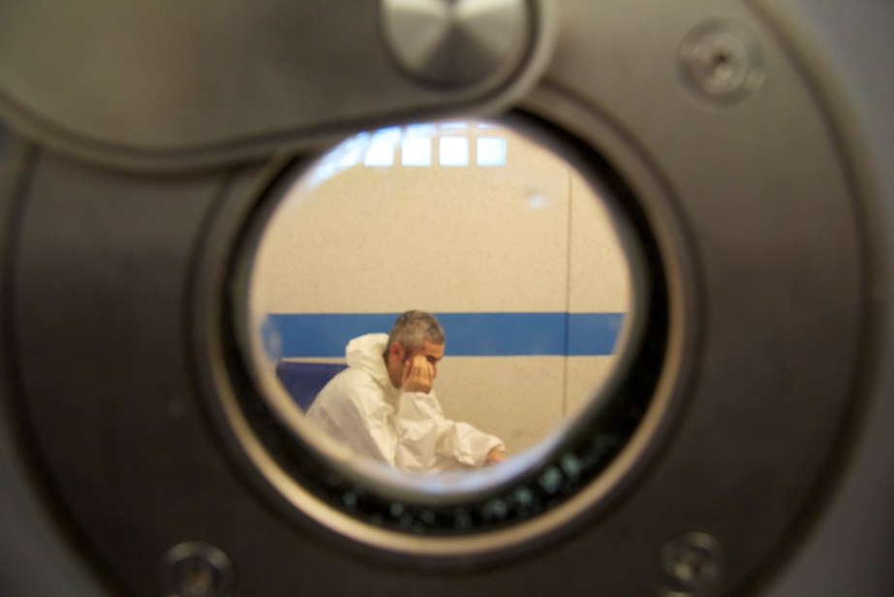
ICVs speak to detainees, asking them about their experiences and check that they’ve been given their legal rights and entitlements. ICVs check all areas of custody including cells, kitchen areas, interview rooms, store cupboards, medical rooms, corridors, shower and toilet facilities etc. Issues of poor standards of cleanliness are often reported in one area of custody whilst the report might also comment on good standards of cleanliness in another area.

ICVs should have immediate access to police custody but accept a short wait is acceptable for certain reasons such as a health and safety issues or if ICVs arrive during operational police handover. ICVs should always expect an explanation and can escalate a concern to the Custody/Duty Inspector if they feel it necessary. They complete visit reports, alerting the scheme manager at Essex OPCC of their findings and raising problems or concerns. The Essex scheme also shares findings, themes and learning with the Independent Custody Visiting Association (ICVA) to represent at a national level, as well other schemes in the Eastern region.

ICV Volunteers in Essex visit the following police stations:

- BASILDON
- CHELMSFORD
- CLACTON
- COLCHESTER
- GRAYS
- HARLOW
- *RAYLEIGH
- STANSTED
- *SOUTHEND
- HARWICH (BORDER FORCE)

* As of February 2017 Rayleigh police custody suite closed following the refurbishment of Southend custody where a new 30 cell suite has been built, including a TACT cell and direct video conferencing to Court.

Essex Independent Custody Visitors
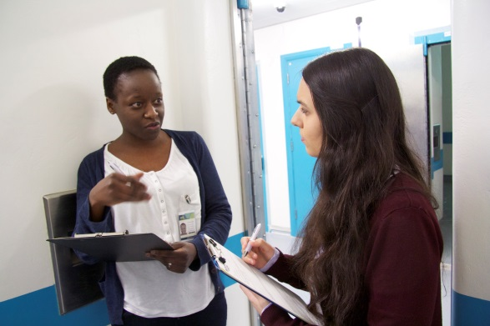
Essex Independent Custody Scheme visitors are residents within the county. Currently the scheme has eighteen volunteers covering nine custody suites across the county with 128 cells. Following the closure of Rayleigh police custody and the temporary closure of Basildon, recruitment for new volunteers is on hold but this is regularly reviewed and will be re-opened when new volunteers are required.
The nine fully operational custody suites are visited at least three times per month by pairs of volunteers with the exception of Harwich and Stansted, which due to their low custody numbers are visited once per month. Volunteers receive yearly appraisals and vetting is renewed as required. The numbers of volunteers with fifteen plus years of service has started to decrease as they have begun to retire. The newest member joined in 2017.

Report Statistics
Each visit results in a comprehensive report being completed by the visitors, noting how many detainees are in custody, how many are being interviewed/asleep/being seen by a medic and how many are s136 and Juveniles. It will also note issues arising with detainees and with the custody suite, alerting the coordinator and scheme manager as appropriate.
Comparison of the number of detainees visited 2015/16 against 2016/17
Since the beginning of 2016 ICVs increased visits to custody suites from two to three per month. When carrying out custody visits a number of detainees may not be able to be seen as they may be in an interview, seeing a medic or sleeping. The overall number of detainees seen by Essex ICVs has risen in the last year from 605 in 2015/16 to 688 in 2016/17.
 | Custody Visit Statistics for April 2016 to March 2017
STATION | NUMBER OF VISITS | DETAINEES | VISITED | DECLINED | JDR | 136 | Not Visited; as either sleeping, interview etc |  | % Visited
BASILDON | 36 | 223 | 140 | 3 | 19 | 6 | 80 |  | 97.90
CHELMSFORD | 36 | 184 | 98 | 1 | 15 | 4 | 85 |  | 98.99
CLACTON | 34 | 135 | 64 | 4 | 9 | 3 | 67 |  | 94.12
COLCHESTER | 31 | 141 | 79 | 1 | 13 | 1 | 61 |  | 98.75
GRAYS | 34 | 150 | 98 | 4 | 16 | 2 | 48 |  | 96.08
HARLOW | 35 | 179 | 104 | 1 | 14 | 1 | 74 |  | 99.05
RAYLEIGH | 29 | 172 | 90 | 6 | 15 | 3 | 76 |  | 94.78
SOUTHEND | 6 | 42 | 10 | 0 | 3 | 0 | 23 |  | 93.75
STANSTED | 11 | 6 | 5 | 0 | 0 | 0 | 1 |  | 100.00
TOTAL | 246 | 1232 | 688 | 20 | 104 | 20 | 515 |  | 95.95
 |  |  | Custody Visit Statistics for April 2015 to March 2016
STATION | NUMBER OF VISITS | DETAINEES |  | VISITED | DECLINED | 136 | Not Visited either; Sleeping, Interview | % Visited
BASILDON | 29 | 195 |  | 104 | 12 | 23 | 79 | 89.65
BRAINTREE | 13 | 43 |  | 26 | 1 | 4 | 16 | 96.29
CHELMSFORD | 30 | 172 |  | 104 | 13 | 8 | 55 | 88.88
CLACTON | 30 | 128 |  | 69 | 4 | 15 | 55 | 94.52
COLCHESTER | 35 | 176 |  | 77 | 12 | 10 | 87 | 86.51
GRAYS | 26 | 159 |  | 98 | 9 | 6 | 52 | 98.98
HARLOW | 25 | 132 |  | 58 | 7 | 4 | 67 | 89.23
RAYLEIGH | 28 | 114 |  | 64 | 2 | 9 | 48 | 96.96
STANSTED | 12 | 7 |  | 5 | 0 | 0 | 2 | 71.42
TOTAL | 228 | 1126 |  | 605 | 60 | 79 | 461 | 90.98
Issues arising from custody visits
Some of the issues and concerns identified by ICVs during this year are as follows;
Estate Issues
A number of Essex custody suites are aging and this can bring estate wear and tear issues such as obsolete buzzers, broken CCTV and ligature points, resulting in cells being out of operation for a number of weeks. Following a visit by HMIC in March, Colchester and Harlow custody suites were identified as having potential ligature sites in the cells and the exercise yard. Colchester had already been closed at the time of the visit to address remedial repairs. Although there are still some ligature point issues these have been mitigated by either using cells that don’t have ligature points for at risk detainees, or where cells with potential points are used, 24 hour observation is put in place. Given the changes in legislation around ligature points ICVs will be offered additional training and development opportunities to learn what constitutes potential ligature points so these can be documented and raised as concerns.
Access to medics
Reports received from ICVs at the time of their visits and anecdotal reports from police staff noted that access to medical care (supplied by G4S) had been taking up to five hours and in some cases even longer. This had been escalated by custody command and there have been signs of improvement, but close monitoring of the situation is continuing and there are still instances of long wait times for detainees requiring medical attention which is unacceptable. Work is being done by the OFPCC and Essex Police around commissioning in respect of medical care going forward.
Custody staff shortages
The OPCC received a number of reports of concern from ICVs over staffing levels in police custody. This has resulted in Stansted and Colchester custody being closed at short notice at various times. Custody officers have raised concerns with ICVs about a lack of staff which visitors have then relayed to the OPCC as it has the potential to impact on the proper monitoring of police custody and if not addressed could prevent officers from responding to additional demands.
Appropriate Adult
There have been concerns raised by ICVs over access to Appropriate Adults for children and vulnerable adults, particularly in certain areas in the out of hours period. Extensive work is being done to liaise with local agencies to provide sufficient cover and to in a previously problematic area within the county there has been significant improvement.
S136 – Mental Health
Custody suites are occupied by those suspected of committing crime, bu may also be used to temporarily accommodate people in need of medical attention or intervention under Section 136 of the Mental Health Act 1983. This enables a police officer to remove, from a public place, someone who they believe to be suffering from a mental disorder and in need of immediate care and control, and take them to a place of safety – for example, a health or social care facility, or the home of a relative or friend. In exceptional circumstances (for example if the person’s behaviour would pose an unmanageably high risk to others), the place of safety may be police custody. Section 136 also states that the purpose of detention is to enable the person to be assessed by a doctor and an approved mental health professional (for example a specially trained social worker or nurse), and for the making of any necessary arrangements for treatment or care. Following the HMIC visit in February, concerns were raised about vulnerable detainees being held in an inappropriate environment such as police custody. At the time extensive work was being carried out by Essex Police and the OPCC with Clinical Commissioning Groups and healthcare agencies to increase the number of mental health beds around the county. From April 2017 Essex Police committed with partners to taking all those suffering from a mental health crisis to a health based place of safety (HBPoS) wherever possible. This is being closely monitored to ensure it is achieved.
Rights and Entitlements
ICVs will always ask detainees about their rights and entitlements. Concerns raised by detainees centre around access to phone calls, being offered food and an update on what is happening. ICVs always check with Detention Officers and against custody records and if needs have not been addressed ensure these are undertaken by the Detention Officer or Custody Sergeant.
HMIC Unannounced inspection visit to police custody in Essex 27th February to 10th March 2017
Following an unannounced visit by HMIC the following ares/issues were identified
Inspectors were pleased to find that:
- staff continued to treat detainees well and were sensitive when dealing with vulnerable people or those from minority backgrounds;
- management of the use of force in custody was good;
- overall, the standard of health care was adequate; and
- in most cases, the force planned sufficient emphasis on ensuring that detainees were released safely.
Inspectors were, however, concerned to find that:
- the force was poorly served by its IT system, which custody sergeants found bureaucratic and difficult to use;
- inspectors identified several potential ligature points, which required attention;
- the force did not comply with all procedures in relation to the Police and Criminal Evidence Act 1984 (PACE) in particular code C and G; and
- despite the force developing relationships with key stakeholders, too many vulnerable adults were brought into custody as a place of safety and too many children were held overnight when alternative accommodation should have been provided.

Harwich Border Force - Independent Custody Visits Summary - April 2016 – March 2017

Summary of Visits
Essex Office of the Police and Crime Commissioner and the ICV Scheme took over the visiting of Harwich Border Force Custody Suite in the beginning of April 2016. Given the relatively low number of detainees going through custody, the ICVs combine unannounced visits with visits that follow a call from Harwich Border Force advising a detainee has been taken into custody. This combination enables an adequate weight of unannounced visits and expected visits where ICVs are able to interview detainees.
Number of visits carried out by ICVs in the period covering April 2016 to June 2017 | 14
Number of detainees in custody at the time | 6
Number seen by ICVs | 4

Treatment of Detainees
Detainees reported that they were happy with their treatment and understood why they were being held in custody. Detainees were offered food and drinks. The food provided to detainees was of a good range and the kitchen area was always very clean. Detainees were given access to interpreters where necessary, although staff reported getting hold of interpreters could be problematic on occasions. Records seen by ICVs showed that detainees had been held within PACE guidelines. Harwich custody has an exercise yard to which detainees are given access.
Environment Issues
There were some environment issues such as paint flaking off the wall, which could be a potential self-harm issue. The black strips along the corridor had also begun to peel away. These were raised with the escorting officer and were subsequently addressed.
Intermittent light issue in corridor | Resolved
Leaking shower | Outstanding
Signs of damp on the wall facing booking-in desk | Resolved
Plastic guard strip peeling off wall | Resolved

Custody Staff
The ICVs consistently found Harwich Border Force staff to be helpful and accommodating. They took time to explain the role of Border Force and how it differed to that of the Police. Staff were extremely open and transparent when offering ICVs access to custody records. ICVs were confident that detainees were treated well throughout the custody process.

Conclusion
The scheme in Essex is fortunate in having a number of very experienced volunteers who check on detainee’s rights and entitlements as well as issues with the state of custody suites and store cupboards. Although the number of detainees going through custody are falling, the increase in visits mean that the number of detainees being seen by ICVs have gone up. Any concerns raised by individuals are consistently followed up on, something that was reflected in the HMIC report.
The recent restructure of ICVA this year has been really useful in the distribution of information as well providing bite size training packages to ICVs, and these updates will be fed back to scheme members at future meetings so members are kept up-to-date with legislation and what to look for when in a custody suite.
The report by HMIC raised a number of issues the most concerning of which were the detainment of vulnerable people and children in custody where alternatives should be sought. However, following on from the collaborative work being done earlier in the year and the commitment by Essex Police that the number of s136 should start to decrease as they are taken to HBPoS, we are confident this will be addressed over the subsequent months.
Looking Forward
The scheme provides a lot of valuable information not only about the treatment of detainees, but custody as a whole. Looking forward a quarterly briefing will be produced that will feed through the OFPCC Performance and Resources Board.
The quarterly meetings will also be attended biannually by the deputy Police, Fire and Crime Commissioner, who will lend her support to the volunteers and back up the importance of what they do.
Custody visitors will also have a focus on key themes and issues that are occurring in custody in order to help inform the experiences of those going through custody.
The scheme coordinator will also actively seek to bring more diverse volunteers to the scheme so as to enable a broader range of viewpoints to bring to the custody experience.
The OFPCC will also work hard to influence agencies to provide fit for purpose Appropriate Adults for children and vulnerable people that is inclusive of all those affected in custody suites across the county.

