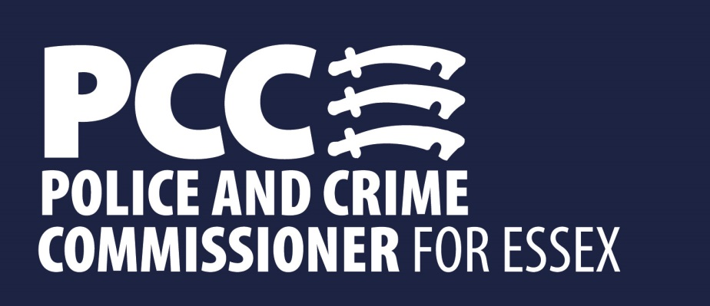

Office of the Police and Crime Commissioner
Notes from the Maldon Public Meeting
Held at the Council Offices, Princes Road, Maldon
On Monday 27th February 2017 at 7pm

Panel Members
Police & Crime Commissioner, Roger Hirst,
Community Safety Partnership Manager, Spencer Clarke
Chelmsford and Maldon Ch/Insp, Ronnie Egan
Chaired by Cllr Mark Heard

Co-location of Maldon Police Station with Maldon District Council
The PCC explained how co-location between the Police, Councils, Community Safety Partnerships has been working really well in other areas such as Colchester and Southend. He gave the assurance that Essex Police would remain in the town. The new offices would also enable increased opening hours and better shared intelligence and knowledge of the local community. He also explained that the aim was that officers would not be in the building they would be deployed in the area.
Land Ownership - it was asked when the constabulary purchased Maldon police station and the land, as there was a possibility that the land was gifted to the community in 1912, in which case the land does not belong to the PCC and cannot be legally sold. It has been confirmed subsequent to the meeting that Maldon Police Station was transferred to Essex Police Authority in 1995 and it is therefore part of the Police estate.
Petition – A petition asking for Maldon Station to remain open has been signed by 750 residents as it provides local, visible policing. Furthermore Maldon police station is a historic building and forms part of Maldon’s culture. 750 people are asking the PCC to keep the station open so why is he intending to close it? The PCC said it’s a fact that the majority of crime is reported to the Police via phone and online. The number of people coming into the station is very low. Only about seven people on average a day and many of these people actually need the support of other agencies. The main reason for moving are the benefits of co-location and the improved service this would offer the public.
Car-Parking – Where will the police vehicles be parked in the new offices? Extra parking has been made available for police vehicles, but the expectation is that officers will be out on patrol and not sat in the office.
Custody – What will happen to the custody suite at Maldon Station? The custody suite at Maldon station has not been in operation for a number of years. Those detained are taken to Chelmsford, Colchester or one of the other suites in the County.
Alleyways – Would the council consider providing lighting in the alleyways that lead through to the council offices? Spencer Clarke, CSP Manager agreed that this could be assessed.
Financial benefits – What are the financial benefits for co-location? The PCC sees the main benefit as bringing together agencies in a hub, providing much better collaborative working. However, the clear financial benefits would be saving over £140,000 that would otherwise need to be spent on maintenance and saving of £20,000 per year in running costs. The sale of the building would also generate around £500,000.
Cllr Lewis added Maldon council has been looking to maximise their building for rent and they were approached by Essex police about discussions to use their premises. The old council building had asbestos and following its rebuild new offices have been created and were currently occupied by the CAB, DWP and Homestart.
Keeping the station on its current site will help with public reassurance. As there isn’t local, visible policing currently happening police stations with cars parked outside and lights being on during the night gives us this, so why relocate away from the high street? The PCC said that the decision has been taken to provide more effective collaborative working and a better service to the public. The police station is not open at night and the new space will actually have longer opening hours.
What have the police gained by closing rural stations? Maldon station is being used by police so why shut it? The PCC stated that this move is about the benefits of co-location. We have seen in other areas such as Clacton the benefits to the public of putting services together in the same space. Policing has changed and we don’t want police sat in stations waiting to be called but out on patrol in their communities.
Why can’t the money that’s currently being spent on mobile technology be used on keeping Maldon police station open instead? The PCC said that we need to invest in technology to enable officers to stay out and about in their communities rather than sitting paper work.
Mobile phones often can’t get signals so how do you intend to use them? Mobile technology is a useful additional tool and helps save time by allowing officers to complete tasks while they are out in their communities. It doesn’t replace other ways of communicating. The main benefit of mobile technology at the moment is that it allows officers to access the police computer system and complete simple tasks. Police officers still use radios for communication.
Why isn’t the PCC selling his offices in Hoffmann’s Way, Chelmsford? The PCC clarified that he is selling Hoffmann’s Way and looking to co-locate on a shared site.
Lack of Police Visibility in the Rural Community
Farm Vehicle Theft – A resident in the rural community had been a victim of farm vehicle theft and was very frustrated that it took two weeks before a police officer attended to take a statement. In addition a report to the police at the weekend around hare coursing and subsequent threats made by the individuals involved had resulted in a poor response time from the police. This was later followed up with a phone call from Essex police firearms licensing to discuss removing his gun licence. He asked when the police would take rural crime seriously. Ch/Insp Egan agreed to look into the specifics of the incident raised. She added that police were taking hare coursing seriously as in the recent Operation Galileo which centred around hare coursing.
Ch/Insp Egan to look into the hare coursing and subsequent firearms enquiry
Cllr Bass also feels rural crime is a huge issue and currently there is not adequate resourcing provided by the police. This needs to be addressed as the community feels threatened and let down. Cllr Durham agreed adding there was evidence that some elements of the traveller community were responsible but the police refused to act.
Spencer Clarke, CSP Manager is currently making recommendations that rural crime is a priority for the Community Safety Partnership. This then becomes a priority for the Community Policing Team and subsequently data sharing becomes so much better.
ANPR
Do police vehicles have ANPR (Automatic Number Plate Recognition) in their vehicles? Some vehicles are equipped but the majority of officers have access to the control room who check data. The PCC has also invested an extra £100k in ANPR.
Increased Police Visibility & Presence
When will there be increased police visibility? The PCC is committed to providing more local, accessible and visible policing, in particular doubling the Special Constabulary. The PCC also stated that he had recently raised the Council Tax Precept to fund 41 new front line officers. Ch/Insp Egan also stated that she has put more Specials and PCSOs on foot in the high street to provide reassurance and visibility
CCTV – Will there be more CCTV in the town as there have been a number of high street burglaries? Spencer Clarke, CSP Manager said that he is currently in the process of upgrading the town’s CCTV system and while this may not mean more cameras, the new cameras will be HD quality and utilised better.
Visiting crime scenes – I am in favour of closing police stations if it means we can have more police officers visit crime scenes. The PCC stated that he also wants officers to be out in their communities or solving crime.
Roads
The signage on country roads is very poor and needs to be improved to ensure enforcement of speeding which is currently an issue in rural communities. Can the PCC look at rural area of community for speeding? The PCC is both a member and advocate of Speed Watch. Signage comes under Essex Highways in conjunction with partner agencies, and if there are areas that need improving then this can be assessed. Earlier last year the PCC approved finance for a crew-cam which carries out additional parking enforcement in the area.
The A12 and A120 are regularly closed due to accidents and incidents creating huge traffic jams that can last for hours. It is usually EFRS who close the road, invariably shutting off both lanes. If the PCC takes on the role of fire commissioner could he look to prioritise opening the roads more quickly? The PCC said that this is an area he would like to look at in the future depending on what happens with the current consultation.
Fire Collaboration
How much more will the PCC be paid if he becomes the Police, Fire and Crime Commissioner? The PCC stated he will not get a penny more.
What is the PCC’s accountability? The PCC is elected and thus accountable to the public.

