**Briefing Note for the Chelmsford Police and Crime Commissioner Meeting 2nd March 2017**

Version:1.10.0.3

Hash:aRVa0p3TI0aY+Np/tcroQ6S7N/I=



**Chelmsford District Profile**

Chelmsford is part of the North Local Policing Area (LPA), which is sub-divided into four District Policing Areas (DPAs). Chelmsford and Maldon jointly form a single DPA under the command of a District Commander.

The city of Chelmsford is situated in the heart of Essex and covers 133 square miles. Chelmsford has a population of 168,310 (based on the 2011 Census), which amounts to just under 12% of the total population of Essex. Anglia Ruskin University has over 6,000 students, which increases the population of the city significantly during term-time. Chelmsford is only 35 minutes away from London by train and is within easy access to Stansted and Southend Airports.

Chelmsford was awarded city status in 2012. Whilst the city is a focal point, the area also includes the town of South Woodham Ferrers, plus several villages and open countryside - of which over a third is designated as ‘Green Belt’.

Chelmsford is an affluent area with excellent visitor attractions. The city hosts a variety of events and festivals including the ‘V’ Festival at Hylands Park. There is a thriving night-time economy, with a licensing capacity of over 15,000 which is often reached on Wednesday, Friday and Saturday nights.

**Policing Structure and Resources**

Local Policing Team (LPT) – Established September 2015

The LPT consists of six teams, which are based at Chelmsford Police Station and work shifts to cover the district 24 hours a day, seven days a week. Each team is supervised by an Inspector and deals with a range of policing duties, including incident demand, appointments and missing persons. The number of officers on each team varies due to vacancies, but the model provides for one Inspector, two Sergeants and 15 Constables on each team at Chelmsford, with a further two Sergeants and four Constables at Maldon.

The Chelmsford teams are sometimes required to provide additional support to Maldon, which also forms part of the DPA.

The LPT is supported by 27 Special Constables.

Community Policing Team (CPT) – Established May 2016

The CPT comprises the following uniformed resources: two Sergeants, 11 Constables (including a Child and Young Person Officer), ten Police Community Support Officers (PCSOs) and ten Special Constables. The team is managed by an Inspector, who is responsible for community policing, engagement and problem solving. In addition, the team is supported by a Licensing Officer, a Crime Prevention Tactical Advisor, an Essex Watch Coordinator, an Anti-Social Behaviour Coordinator and a Missing Person Liaison Officer.

The uniformed resources are currently split into two teams - one based in Chelmsford and the other in Maldon. The Chelmsford team and support staff operate from Chelmsford police station. Negotiations are taking place to create a Community Safety Partnership Hub in the Chelmsford City Council offices. This is in an early stage of negotiation, and it is not possible to say when this may happen. However, it should be noted there is strong support for this concept from the local authority. The Maldon team are currently based at Maldon Police Station but will soon be co-located with the other team at Chelmsford, in order to operate from a central hub location that covers both local authority areas.

Criminal Investigation Department (CID) and Juno Team

Based at Chelmsford, CID has three teams of detectives, led by a Detective Inspector. CID investigates the more serious crimes such as robbery, grievous bodily harm and dwelling burglary.

All high-risk domestic abuse allegations are investigated by the Juno team, which is also based at Chelmsford and is line managed by a separate Detective Inspector.

**Community Concerns and Media**

Gang Related Crime (Including Knife Crime)

The movement of drug lines from London into the area has continued and is actively targeted by Operation Raptor and the CPT. There has been some significant disruption across the city and work continues with undertaking a number of drug-related warrants and other enforcement in the local area.

Under the current force tasking model, Chelmsford has an organised crime gang which is being managed by the LPA. This activity is being renewed through the Disruption Panel, especially in light of links between the activities of the gang and the exploitation of young persons, some of whom are regularly reported as missing persons.

Night-Time Economy

Chelmsford has a vibrant night-time economy (NTE) which can result in up to 15,000 people visiting the city centre on any one night. In 2014, the council consulted on a proposal to introduce a night-time levy on certain licensed premises. Revenue raised from the levy is being used for local initiatives relating to the city centre and the NTE.

The local Community Safety Partnership coordinated the successful reaccreditation of the city of Chelmsford under the ‘Purple Flag’ scheme, which included the adoption of the University of East Anglia estate within the scheme. This reflects its on-going support to schemes such as Street Pastors, Taxi Marshals, Nights of Action and the launch of a ‘Purple Place’ initiative, which provides a city centre safe haven for people enjoying the NTE, if required. This is further supported by a new initiative called Best Bar None (BBN), which 15 of the city’s licensed premises are taking part in. One of the South Woodham Ferrers premises won a BBN award at the first annual awards night.

Rural Police and Other Areas

Rural crime and supporting rural communities remains an issue. Resources attend incidents based on levels of threat, harm and risk, which can result in rural communities feeling vulnerable and overlooked. These concerns are also expressed in towns and villages such as South Woodham Ferrers and the outlying areas of Chelmsford. The DPA will be working with the Community Safety team to ensure renewed working on rural issues this coming year.

**Problem Solving Initiatives**

South Woodham Ferrers Town Centre - Anti-Social Behaviour

Towards the end of autumn 2016, several reports were received in relation to an increase in ASB in the town centre, South Woodham Ferrers. This related to young people taking ‘legal highs’ and being a general nuisance to shop owners and customers in the town. Not only were calls being received at the Force Control Room, but there had also been an increase in comments being made by local residents over social media. In addition, officers from the Community Policing Team received emails from concerned residents, along with the photographs of the mess and the metal canisters that had been left behind.

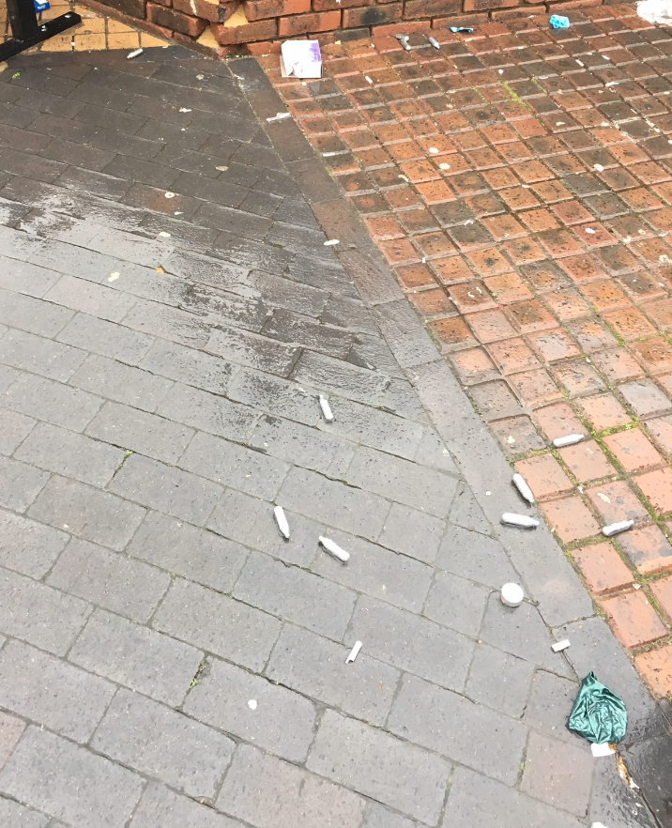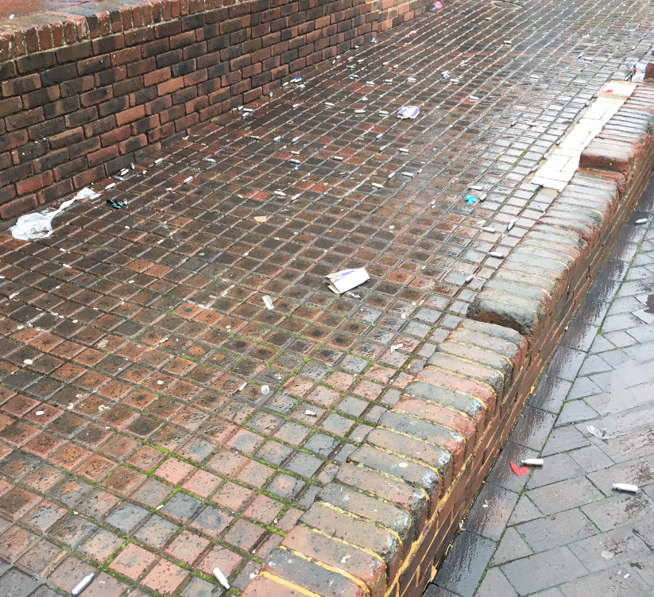

The following email was received from a concerned resident:

*“Friday and Saturday nights in our town have been quite disturbing to a number of people; I have also been discussing this with Chelmsford City Council who I believe have raised concerns, as have the town council. Attached is a photo taken on a Saturday morning where a significant quantity of metal canisters and balloons can be seen. Last Saturday there were, in addition to canisters, various cans and roll-up papers.”*

Over the following month, the Community Policing Team concentrated their efforts in and around the town centre and also worked alongside a local school on some pro-active joint operations. Ongoing work in the town by the Community Policing Team, the Children and Young Persons Officer and the William De Ferrers School, identified concerns that some students and ex-students may be taking drugs during school time. Joint patrols took place between officers and teachers and a number of people were stopped and, where grounds allowed, were searched. Students also received an input into so-called ‘legal highs’ and how they are now illegal and it is an offence to sell such items. Two young adults were issued with Cannabis Warnings and good intelligence was gained from other sources. This intelligence led to a warrant being obtained under the Misuse of Drugs Act, and when executed, a quantity of drugs was found.

On 16th December, a joint operation between the City Council Community Safety Teams and the police took place in the town centre and surrounding areas. The intention was to provide a high visibility presence for reassurance and for enforcement of any offences discovered. Officers were also able to educate young people spoken to in relation to the use of nitrous oxide, although none was seen. This appeared to have a positive effect on the town with several comments being raised and emails of thanks received from a local resident.

In addition, some of the calls which were received in relation to ASB in South Woodham Ferrers related to nuisance vehicles in Asda car park during the evening – drivers were deliberately over-revving their engines and wheel spinning to the annoyance of residents.

Chelmsford City Council was contacted in relation to these issues and the ASB Officer attended Asda and witnessed a small number of irresponsible drivers who were all issued with Community Protection Warning notices. This formally warned the recipient that if they did not stop their current behaviour they may become subject of a Community Protection Notice which could ultimately lead to their arrest. Further patrols have been undertaken by the police which have resulted in a driver being reported for careless driving and Section 59 notices being issued, which if breached may mean the vehicle being seized.

Whilst the issue of ASB will always be a concern, it is hoped that other residents have also seen an improvement within the town centre area.

Harvest Close, South Woodham Ferrers

Calls were received from an elderly resident of Harvest Close who was experiencing ongoing problems with teenagers who were congregating in the evenings at a Children’s (under 12s) play park. The young people had started to throw items at the resident’s house and had on two occasions caused damage to the windows. They were also deliberately depositing rubbish in the front garden and their general behaviour was causing the occupants to feel vulnerable and intimidated.

Officers from the Community Policing Team contacted the ASB Officer at Chelmsford City Council, who was already aware of the ongoing problems and had planned a meeting with the residents to discuss their concerns. The Restorative Justice Hub was also contacted and the problem discussed with them. It was agreed that if the potential suspects could be identified and both parties were agreeable, then a face-to-face meeting could be conducted between them and the victims.

Whilst conducting additional patrols in the area, 12 young people were identified as being potential suspects - they were all aged between 15 and 16 years of age. Over the next fortnight each young person was visited by the police and spoken to in the presence of their parents in relation to how their behaviour was affecting the elderly resident. All of the youths engaged with the police and the parents were disappointed with their child and their apparent disrespect of elderly people. All parties had agreed to take part in mediation, but from follow-up calls to the victims it transpired that the actions already taken had solved the problem and this was no longer required.

The ASB Officer at Chelmsford City Council has also worked with the Parks Department which has undertaken a programme of planting in the area. Eventually the newly planted shrubs will make a natural barrier between the residents and users of the play area.

Operation Gallery

During the month of December 2016, the Chelmsford and Maldon district policing area conducted Operation Gallery. The main aims of this operation were to:

* Reduce crime and protect the public;
* Arrest and process outstanding suspects;
* Provide public reassurance in the form of high visibility patrols;
* Reduce the number of incidents of ASB;
* Gain intelligence in relation to local gangs and active criminals.

Throughout the month, 94 people were stop checked; of which 63 were subject of a subsequent search. 57 vehicles were stopped, of which seven were seized for either having no insurance or because they were being used in the commission of crime. A further 49 arrests were made as a direct result of the operation and five Cannabis Warnings were issued along with two Community Resolutions. As a result of dedicated patrols, 21 traffic related matters were also dealt with. A total of 46 Police Information Reports were submitted which have assisted in building on the intelligence picture for the district.

Of particular note, on 6th December, officers engaged in Operation Gallery attended an armed robbery and were directly involved in the arrest of three suspects. Officers deployed on this operation were also responsible for the arrest of three suspects following a recent burglary.

As part of Operation Gallery, officers were deployed in the city centre using the Ion Track machine which tests swabs taken from people’s hands for illegal drugs. This was used outside night clubs and over 80 people were tested with 14 showing a higher than normal trace and being subject of a further search. One person was issued with a Cannabis Warning. This deployment received positive comments from members of the public waiting to enter the clubs, who felt reassured that action was being taken to prevent drugs being taken into the premises.

Mini Crime Spree in South Woodham Ferrers

During the first few months of 2016, Essex Police received a number of reports of shop burglaries and thefts from shops in the town centre of South Woodham Ferrers. This also included the theft of a number of charity boxes that had been left on the counters in various stores. Officers from the Community Policing Team took on the investigation of these offences and set about securing evidence in relation to these crimes. This involved the copying of CCTV from various stores and premises as well as obtaining numerous victim and witness statements from people in the town.

As a result of their enquiries, officers were able to positively identify the person responsible, and a man in his late forties was arrested, interviewed and subsequently charged with 27 offences. These included offences of burglary, theft, shoplifting and drug possession. This person was sentenced on 15th November 2016, at Chelmsford Magistrates Court, where he received a custodial sentence of 12 months.

**Information from the Serious Crime Directorate (SCD)**

Operation Portland

An investigation by the Major Crime team into the murder of Colleen Westlake and the serious assault on her husband Victor Westlake resulted in Craig Bird, of no fixed address, being convicted at Chelmsford Crown Court on 1st November 2016, and sentenced to 21.5 years in prison for murder and 12 years for assault, to run concurrently. Mrs Westlake was killed at her home in Chelmsford in the early hours of 17th April 2016. Mr Westlake suffered serious injuries.

Operation Dryad

Essex Police launched a complex investigation after receiving intelligence about suspected child sexual exploitation and drug dealing in Chelmsford in December 2013.

During those enquiries, a young woman came forward in April 2014 and revealed how Mohammad Rostami had groomed her into believing she was his girlfriend around seven years earlier, when she was aged just 13 or 14. The exploitation took place from 2006 to 2009 and ended when she left the Chelmsford area. A trial was held at Chelmsford Crown Court from 10th October to 16th December 2016, in which the two men denied the charges against them.

Rostami, a hairdresser, formerly of Shoeburyness, was found guilty of one count of causing or inciting sexual exploitation of a child aged under 18, two counts of sexual activity with a child aged under 16, and three counts of supplying Cocaine, Cannabis and Mephedrone. The jury failed to reach a verdict on a count of rape.

Rostami was sentenced to 15 years imprisonment for the six charges he was convicted of. He also received six years for conspiracy to supply Mephedrone, after admitting the charge at a linked trial last year. His overall jail term was therefore 21 years. He was also made subject of a sexual harm prevention order and a restraining order that will run indefinitely.

Mehdi Zare was sentenced to a total of 12 years imprisonment for the charges he was convicted of. He was also made subject of a sexual harm prevention order and a restraining order that will run indefinitely.

Amin Kaveh was sentenced to a total of ten years imprisonment.

**Chelmsford Crime and Anti-Social Behaviour Performance Data**

Version:1.10.0.3

Hash:bWqc9Tywi9RwJLqtJmOf6q3X7BI=

The table below sets out the crime figures for Chelmsford, comparing reports for 1st February 2015 to 31st January 2016 with 1st February 2016 to 31st January 2017 for the Chelmsford district and the force.

**Areas of note for Chelmsford district:**

* All Crime has increased by 14.2% (1356 more offences);
* Violence without Injury has increased by 26.7% (397 more offences);
* Other Burglary has increased by 24.6% (128 more offences);
* Theft of Motor Vehicle has increased by 38.8% (87 more offences);
* Sexual Offences has increased by 25.7% (61 more offences);
* Shoplifting has decreased by 6.7% (77 fewer offences);
* Anti-Social Behaviour has decreased by 5.5% (241 fewer incidents).

**Other districts – All Crime offences and per 1000 population:**



Violent Crime (All Types)

In Chelmsford district, during the above reporting period, the most significant rise in violent crime was within the Violence without Injury category. This follows a national trend as the result of changes in recording rules, which means this category now includes harassment offences, including sending malicious messages. Approximately a third of violent crimes in Chelmsford district during the reporting period were linked to domestic abuse – 30% of violent crimes (32% of Violence without Injury offences) were domestic abuse related.

With a large NTE there is always the potential for violent offences to occur. Licensed premises which have been linked to disorder are targeted to ensure compliance with licensing regulations. The CPT has responsibility for policing the NTE and appropriate training is being given to support officers in performing this role.

Theft of Motor Vehicles

Although the number of offences of Theft of Motor Vehicle increased by 38.8% in Chelmsford district (87 more offences during the reporting period) when compared with the same period the previous year, no hot spots or crime series have been identified and the issue is district wide.

Sexual Crime

During the reporting period, sexual offences increased in Chelmsford district by 25.7% when compared to the same period the previous year (61 more offences). When considering rape of over 16-year-olds, over one third of the offences were domestic abuse related – 37% of offences of rape of over 16-year-olds were linked to domestic abuse. All serious sexual crime is investigated by the Sexual Offences Investigation Team (SOIT).

There continues to be a steady reporting of historic offences, which suggests members of the public remain confident in reporting issues such as this to the police.

Burglary

During the reporting period, offences of dwelling burglary increased in Chelmsford district by 22% (91 more offences) when compared to the same period the previous year; offences of other types of burglary increased by 24.6% (128 more offences).

Throughout autumn 2016, Chelmsford (and Maldon) saw an increase in dwelling burglaries which was widely reported in the press and media with several people raising concerns over social media. A number of operations were set up to address the issue which included both covert and overt tactics.

Chelmsford CID worked hard in their investigations, with some good results. The work included a three week crime reduction initiative called Operation Gallery, which ran in response to this and other crime concerns. Please see the section on problem solving initiatives for further details on Operation Gallery.

The maps overleaf show a comparison of the offences of dwelling burglaries reported to the police over the last four months. Each red circle represents a single offence.

Map 1 shows the offences reported between 1st September and 30th November and map 2 shows the offences reported between 1st December and 5th February.

Map 1 Map 2

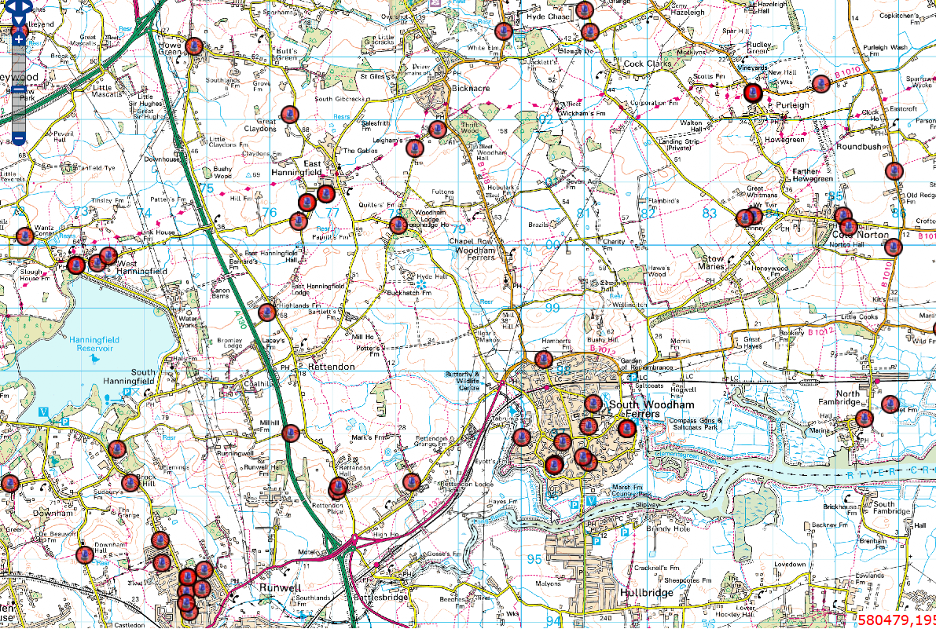 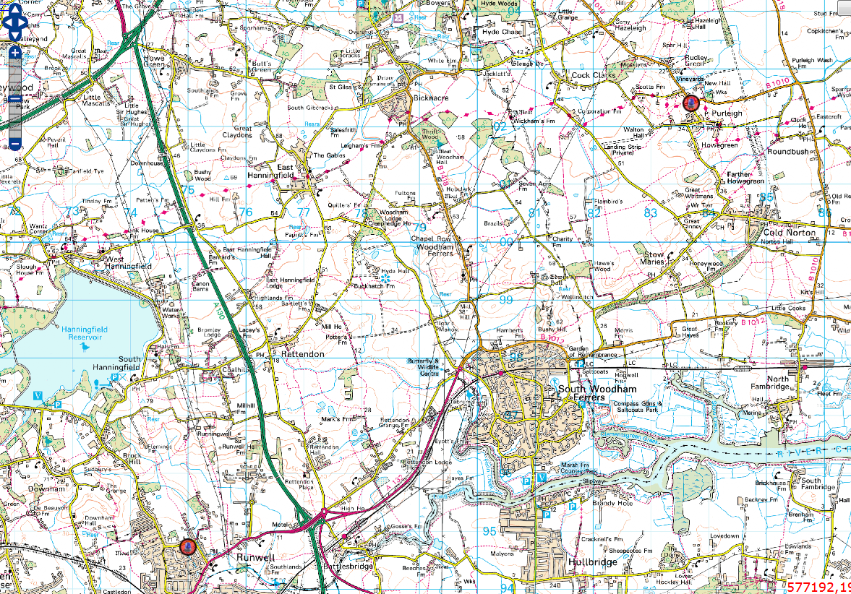

Anti-Social Behaviour (ASB)

During the reporting period, ASB decreased in Chelmsford by 5.5% (241 fewer incidents) when compared to the same period the previous year. Incidents of ASB that involve the greatest harm now form part of the force tasking process. Chelmsford has identified its top priorities, which will be reviewed at the next CSP tasking meeting and appropriate action plans will be set.