ESSEX POLICE, FIRE AND CRIME COMMISSIONER FIRE & RESCUE AUTHORITY
Essex County Fire & Rescue Service
Meeting | Service Leadership Team | Agenda Item | 9
Meeting Date | 29 August 2018 | Report Number
Report Author: | Risk & Business Continuity Manager
Presented By | Risk & Business Continuity Manager
Subject | Risk and Business Continuity Monthly Report
Type of Report: | Information

Recommendations
That the Board note:
- the new Strategic Business Continuity and Recovery Policy;
- the accompanying Strategic Business Continuity and Recovery Plan; and,
- the contents of the report.

BACKGROUND
This report updates the Board on the current position regarding Risk and Business Continuity management. It also covers the draft policy and business continuity and recovery plan.

Options and Analysis
Risk Management
Appendix A to this report contains the current Amber Strategic Risks, those totalling 12 were reviewed at August’s SLT meeting.
A draft audit report has been received by the Service commenting on the Service’s performance on the Risk Action Plan. One area was highlighted and needing more progression (though elements of this have been challenged), which was having the Service’s Risk Profile reviewed at the end of each SLT meeting. This has now been added as a standard agenda item for SLT at the end of each meeting.
Business Continuity
A revised draft Strategic Business Continuity and Recovery Plan is attached as Appendix B. This provides the foundation of arrangements in place in the event of an incident, to refine with SLT comments and suggestions as soon as practicable. Having sound business continuity arrangements is a statutory responsibility of a Category 1 Responder under the Civil Contingencies Act 2004.

The current situation regarding business continuity planning is as follows:
- A programme of Control Live Exercises is currently underway, the exercise scenario requires Control to invoke Business Continuity, relocate and set up secondary control. The programme of exercises is planned to be complete in July 2018, at which time a post exercise report will be produced.
- The programme of departmental BC Plan reviews has made good progress, with only one Plan (Finance) outstanding.

- The project to introduce supply chain continuity is underway, led by the Purchasing and Supply Manager. Meetings are being held with departments, such as Technical, Property and ICT to identify critical suppliers and contractors. A supply chain continuity policy has been developed and is included in the overarching BC Policy for the Service.
- The Risk & Business Continuity Officer has approached ICT for clarification regarding its position on developing an ICT Disaster Recovery Live Exercise.
- A wider programme to exercise/verify the business continuity arrangements of other departments is in development and will be implemented following approval of the Strategic Business Continuity and Recovery Plan.

Benefits and Risk Implications
Included within the report.

Financial Implications
None at this stage.

Equality and Diversity Implications
None at this stage.

Workforce Engagement
The new Policy and Strategy has been widely shared with all department heads, but these will now need to be exercised to develop full awareness with the Service.

Legal Implications
None at this stage.

Risks
New
Opportunity
Appendix A

Prevention |  | Protection |  | Response |  | People & Leadership |  | Public Value & Collaboration
Staff and/or volunteers fail to recognise & take appropriate action where a 'Safeguarding' issue occurs. |  | Through its Prevention activity, the Service fails to identify and ensure effective control of risks (enforcing where appropriate) within the Essex community. |  | Death or serious injury to staff, or death or serious injury to member of the public, at an incident. |  | The Service fails to implement a new people management system (HOBs) effectively leading to inefficient management of resources and incorrect payment of personnel. |  | The Service receives a poor HMICFRS Report
False or inaccurate data limits the Service's future planning and decision making leading to the service is unable to plan or deliver and effective or efficient service. |  | The Service does not, or is not able to, respond effectively to the outcome of the Grenfell Inquiry |  | Service unable to effectively communicate with our mobile assets and partner agencies (including ESMCP & COMOS Projects). |  | Through new legislation or changes in interruption of current Law/Regulations, one of the Services crewing systems is not sustainable. |  | The Service does not deliver changes set out in the 2020 programme which identified financial savings and thus cannot deliver against its medium term financial plan.
 |  |  |  | The Service fails to prepare or plan effectively, in line with Civil Contingencies Act (2004), leading to an inadequate response to an emergency |  | Failure to manage and implement learning arising from incidents within Essex and also National events |  | Failure to deliver the (incoming) Essex Fire & Rescue Plan and/or PFCC Local Business Case.
 |  |  |  | Opportunity to develop and implement new or revised firefighting procedures and techniques. |  | Failure to deliver against our People Strategy. If we do not have motivated and engaged people with the right skills and competencies, with appropriate succession planning and career development, there is a risk that we will be unable to innovate and deliver safe and effective services to our communities. |  | False or inaccurate data limits the Service's future planning and decision making leading to the service is unable to plan or deliver and effective or efficient service
 |  |  |  | If we have a significant failure, loss or reduction of our physical infrastructure or resources (including our people) there is a risk that we will not deliver the same level of prevention, protection and response services to our communities. |  | The Service fails to encourage and establish a culture which creates a work environment in line with the Service values |  | If we have a large or unexpected loss in our income or cash there is a risk that we will have to reduce the level of core functions we provide to our communities.
 |  |  |  |  |  | The Service does not provide the training facilities and resources in order to ensure the safety of operational staff in line with the Health and Safety at Work Act |  | The manner in which the Services stores and/or manages it data fails to meet the requirements of the Data Protection Act 1998 and the General Data Protection Regulations (EU 2016/679)
 |  |  |  |  |  |  |  | If the ECFRS is able to react in an agile way to changes in our environment there is an opportunity to identify new and effective ways to deliver our services.
 |  |  |  |  |  |  |  | Change in political climate/direction Nationally and/or in Essex.
 |  |  |  |  |  |  |  | The Service fails to collaborate effectively with partner agencies and thus does not comply with the Policing and Crime Act 2017
 |  |  |  |  |  |  |  | Failure in the Service's Information, Communication and Technology (ICT) infrastructure, leading to intermittent or loss of service or current ways of working are not fit for purpose.

Strategic Business Continuity Plan
Response & Recovery Framework

Version: | 2.0 | Dated: | July 2018
Protective Marking: | Official | Formal Review: | July 2021
Plan Owner: | ECFRS, Senior Leadership Team
Plan Author: | Risk & Business Continuity Officer

DOCUMENT MANAGEMENT

Prepared by: | Risk & Business Continuity Officer
Authorised by: | Corporate Risk & Business Continuity Manager
Approved by: | ECRFS Senior Leadership Team
Updated: | July 2018
Next Formal Review Date: | July 2021
Validated: | To be Validated - Autumn 2019

Storage
Printed copies of this plan may not necessarily be up to date, current versions of the plan are available from the Risk & Business Continuity Team. A copy of the plan is stored on Resilience Direct (https://collaborate.resilience.gov.uk/RDService/home/14171/07.-Plans) and within CIT.

Plan Review Policy
This plan will be reviewed every 3 years in line with the Business Continuity Management Policy. Early review will be considered to implement recommendations from debriefs of incidents or exercises, significant changes to the organisation or the capabilities referenced in this plans.

Business Continuity Management Policy
This document supports delivery of ECFRS’s Business Continuity Management Policy.

DOCUMENT STRUCTURE
Page Number
Introduction & Background 4

Phases of a Business Continuity Incident 5

Section 1: Major Incident 7
1.1 Initial Actions
1.2 Incident Notification
1.3 Major Incident Declaration

Section 2: Command and Control 13
2.1 Command Structure
2.2 Crisis Management Team

Section 3: Response 17
3.1 Developing a Strategy
3.2 Crisis Management Meetings

Section 4: Recovery 25
4.1 Recovery Co-ordination Group
4.2 Recovery Structure

Section 5: Roles & Responsibilities 29

Section 6: Debrief 33

Section 7: Appendices 35
1 Actions Aide Memoire
2 Guidance for Crisis Management Team
3 Designated Relocation Sites
4 Critical Activities
5 Communications

INTRODUCTION & BACKGROUND

Aim
This plan is the strategic level document that outlines the framework to respond to and recover from a business continuity incident, which could impact the ECFRS’s ability to provide vital services to the communities of Essex.

Plan Objectives
- To outline command, control and coordination (C3) arrangements.
- Process for the implementation of business continuity and recovery.
- To set out agreed roles and responsibilities involved in response and recovery.
- Process for the return to normality

Integration
This plan is supported by the following documents which can be found with the relevant departments or within the Plans folder on Resilience Direct by following this URL (https://collaborate.resilience.gov.uk/RDService/home/14171/07.-Plans).

- Business Continuity Management Policy | - Station Business Continuity Plans
- Departmental Business Continuity Plans | - Station Business Continuity Strategy
- ICT Recovery Plans/Procedures | - CIT Plan
- Industrial Action Plan | - Fuel Plan
- Infectious Disease Staff Plan | - Emergency Evacuation Procedures (KP)
- Severe Weather Plan

Legislation
This document has been drafted in line with legislative requirements which are detailed in the Business Continuity Management Policy (see page 2).

Scope
This document details the Response & Recovery Framework for an incident which has an impact on the ability of ECFRS to deliver critical services. This could be caused by denial of building access, loss of infrastructure or loss of People.

PHASES OF A MAJOR BUSINESS CONTINUITY INCIDENT

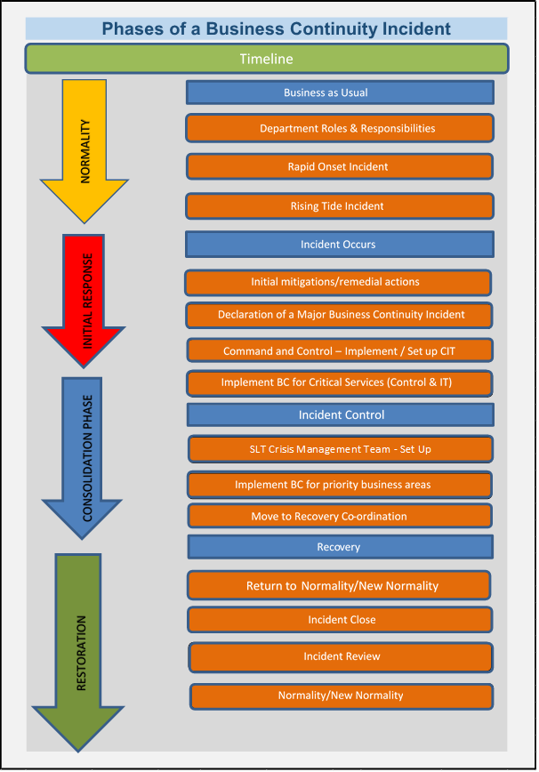

This page has been left intentionally blank

Section 1:
MAJOR INCIDENT

Content Page Number

1.1 Initial Mitigating / Remedial Actions 8
Building Evacuation 8
Infrastructure Failure 9
Loss of People 10

1.2 Incident Notification 11

1.3 Major BC Incident Declaration 12

1.1 INITIAL MITIGATING/REMEDIAL ACTIONS

Initial response to any incident should prioritise:

- Safety and welfare of staff and visitors
- Functionality of Control and operational response
- Reducing the impact on the assets of ECFRS
- Continuation of ICT

Building Evacuation / Closure

Technical Infrastructure Failure

Loss of People

1.2 INCIDENT NOTIFICATION

Notification
Any Business Continuity incident that will impact the Services ability to delivery front line activities should be reported to Control.
Control will contact the Duty Executive Officer with details of the internal incident in the form of an ETHANE Report.
Following the declaration of a major incident, the Senior Leadership Team will be notified by Control, provided with a METHANE report and advised of next steps.

Notification of a Major Incident

To ensure consistency METHANE is now the recognised common model for passing incident information between emergency responders, partners and their control rooms on the declaration of a Major Incident.

Methane Model

M | Major Incident Declared  - Command structure established or to be established  - Initial response strategy set? If so; what is it and does it include recovery?  - SCG/TCG activated? If so; Time of meeting, location and who is required?
E | Exact Location
T | Type of Incident  - Scale - how significant and widespread is the incident or might it become?  - Impact - how bad is it, and how bad could it become?  - Duration - indication how long it is likely to continue?
H | Hazards - present, potential or suspected
A | Access - routes that are safe to use
N | Number - type, severity of casualties, displaced people
E | Emergency Services  - Responding agencies at scene  - Partner agencies required?

1.3 MAJOR INCIDENT DECLARATION

Defining a Major Business Continuity Incident
An event or situation, with a range of serious consequences, which requires special arrangements to be implemented by the Service in order to continue to deliver critical services to the communities of Essex.

Declaring a Business Continuity Incident
A business continuity incident will be declared by the Duty Executive Officer. Declaring a business continuity incident triggers a predetermined strategic and tactical response from each department of the Service. It takes time for operational structures, resources and protocols to be put in place, with priority being given to critical service delivery.

The Executive Duty Officer may decide that the incident does not require implementation of the Strategic Business Continuity Plan. An assessment of the incident may conclude that the situation and its impact should be monitored until resolution or escalation. Mitigations can be implemented to reduce the impact, business as usual could be adapted or an individual department may implement its business continuity plan with limited impact on the wider service.

Following the declaration of a Major Business Continuity Incident, Command and Control should be set up in order to manage the response to and recovery from the incident.

Section 2:
COMMAND & CONTROL

Content Page Number

2.1 Command & Control 14
Initial Control 14
Command Structure 14
Location of the Crisis Management Team 14

2.2 Crisis Management Team 15
Frequency of Meetings 15
Telephone Conference 15

2.1 COMMAND & CONTROL

Initial Control
The Duty Executive Officer will request the setting up of CIT to manage the response to the internal BC Incident (see CIT Plan).

Command Structure
The Executive Director is responsible for leading the response to the incident and formulating the strategy for the incident. The Executive Director may nominate an alternative to lead the response to the incident, for example the Duty Executive Officer. The Senior Leadership Team, along with other senior officers as appropriate to the nature of the incident, will form the Crisis Management Team CMT. The CMT will lead the resources within their Service areas and make the decisions linked to the implementation of the business continuity and the recovery strategy for the organisation, supported by CIT.

INCIDENT COMMANDER:
Executive Director

CRISIS MANAGEMENT TEAM:

Senior Leadership Team
As appropriate to the incident:
Property Services
ICT
Human Resources
Fleet Workshops
Communications

INCIDENT CO-ORDINATION:
- CIT Lead
- CIT Team

Location of the Crisis Management Team Meetings

CMT should be located where they can most effectively undertake their responsibilities, and should remain detached from the immediate response activities.

There will be occasions when this is best achieved remotely from them the incident, for example following denial of access to Kelvedon Park, when Rayleigh Weir Station will be utilised

2.2 CRISIS MANAGEMENT TEAM
The membership of the CMT will be determined by the Executive Director and will consist of those Departments thought necessary to effectively manage the agreed aims and objectives and to achieve a resolution of the incident at the earliest opportunity.

Whilst the exact membership of the CMT will be incident specific, consideration should be given to the involvement of all SLT members.

The Chair should seek to maintain the membership of the CMT at a workable level requiring only those individuals essential to the decision making process to attend. Attendance should be limited to one Senior Manager for each Department, who must hold sufficient authority to make decisions concerning the resources of the department.

Records and Logs of meetings should be taken, particularly key decisions taken (with rationale). These provide an aide-mémoire of the development of the response and may be called at subsequent legal proceedings. The Executive Director will be supported by the Executive Support Team, whose responsibility will be to record the meetings.

Consideration should be given at the early stages to the personal resilience of the members of the CMT. Working on a response can be intense, welfare should be considered including limiting the duration of shifts and implementing a rota of deputies.

Frequency of Meetings
The Executive Director will seek to form the initial meeting of the CMT at the earliest reasonable opportunity. Early consideration needs to be given to the frequency of meetings enabling officer time to pre-plan their attendance and to ensure that operational activity/meetings are synchronized to ensure that the information upon which decisions will be based is readily available.

Telephone Conference
Where the Executive Director considers it appropriate co-ordination could be achieved through the use of a telephone conference. This might be appropriate where:
- Communication is necessary prior to a physical convening the CMT
- Attendance at a single place is not conducive to the incident (e.g. a severe weather event)

Officers must be made aware of the telephone conference protocols.
- Log in to the telephone conference 5 minutes prior to the call.
- Phones should be placed on mute when not active on the call.
- Reporting should be by exception.
- Take independent notes of any appropriate actions.

This page has been left intentionally blank.

Section 3:
Response

Content Page Number

3.1 Developing the Strategy 18
Joint Decision Model 18
Considerations 18
Priorities 19

3.2 Crisis Management Meetings 19
Chairmanship 19
Agenda 19
Decision Controls 21
Incident Logs & Information Management 21
Communication Strategy 22
Managing Response 22
Welfare 22
Recovery Issues 22
Formal Handover to Recovery Co-ordination 23

3.1 DEVELOPING A STRATEGY
The Executive Director must establish the immediate and on-going strategic requirements of the incident enabling the appropriate response activity to be undertaken.

The requirements should include the agreed strategic aims and objectives, kept under regular review and should readily be available to all CMT Members.

Joint Decision Model
In order to contain the incident it is advisable that any documented strategy should be developed using the JESIP Joint Decision Model.

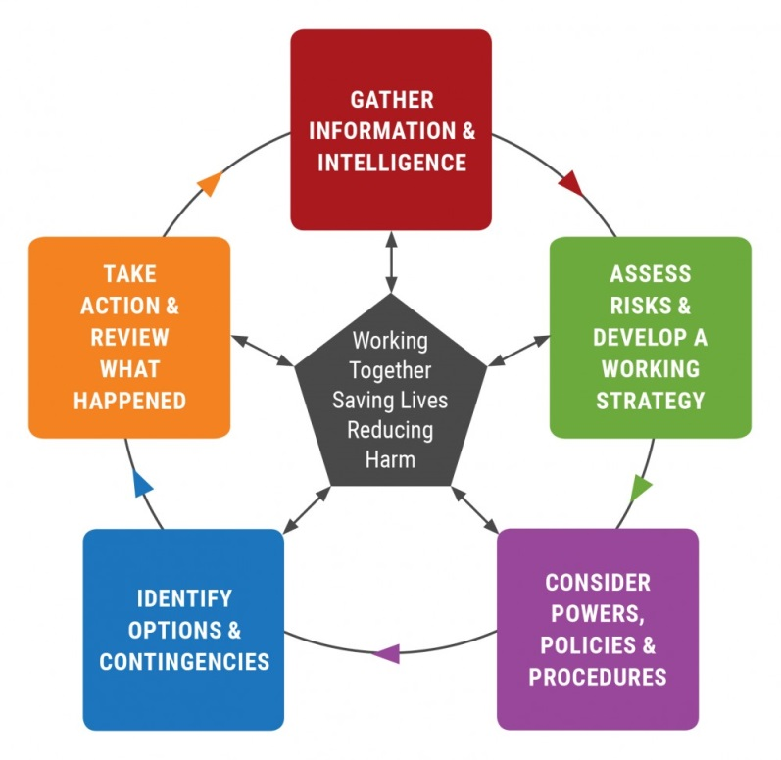

Considerations
When developing the strategy the following issues should be considered based on an understanding of the nature, impact and estimated duration of the business interruption:
- Safety and welfare of staff and visitors
- Safety and welfare of communities
- Containing the interruption, limit escalation and mitigate impacts
- Maintaining functionality of Control and operational response capability
- Implementing a Command and Control Structure (as detailed in this document)
- Recovery of ICT Systems as appropriate
- Implementation of Departmental Business Continuity Plans (including relocation of departments and remote working)

Priorities
Recovery of the organisation will be spread over a number of days. It is necessary that the higher priority activities are placed at the head of the queue. The CMT must ensure that the resources of the organisation are allocated to ensuring that those departments that have the biggest impact on the delivery of the Service are recovered first (see Recovery Priorities Appendix 4).

It is recommended that, depending on the nature and severity of the incident, that business continuity is implemented for each Recovery Priority in turn (starting with Recovery Priority 1).

Departmental recovery priorities for enabling functions are identified utilising the following table:-

Recovery Priority | Timescale
1 | Recover Immediately
2 | Recover within 1 day
3 | Recover within 2 days
4 | Recover within 1 week
5 | Recover within 1 month
6 | Recover within 3 months

3.2 CRISIS MANAGEMENT MEETINGS

Chairmanship
The Executive Director will chair the CMT Meetings, but may choose to nominate an alternative as appropriate.

The Chair will ensure:
- A strategy for the response to and recovery from the incident is defined.
- Creation and dissemination of a Situation Report (SitRep);
- Implementation of an effective command structure with clearly defined lines of communication;
- Simplified joint decision making procedures together with clear and timely direction;
- Clear prioritisation of tasks;
- Allocation of resources.

Example CMT Agenda

This example CMT agenda. It can be further developed as appropriate to the situation.

1. Situational Awareness (METHANE)
- Supported by lead department
(e.g. Property for loss of building, ICT for Infrastructure failure)
2. Membership of CMT Meetings
3. Joint Understanding of Risk - Significant Issues / Horizon Scan
4. Agree/Review the Strategy for Response to Incident

5. Immediate Tasks / Objectives

6. Recovery Strategy / Actions

7. Communication Strategy
- Internal with staff
- External Stakeholders
- External Media / Public
8. Next Meeting / Time etc
Internal with staff

Decision Controls

The following decision controls from the JESIP Doctrine may be utilised to support CMT decision making.

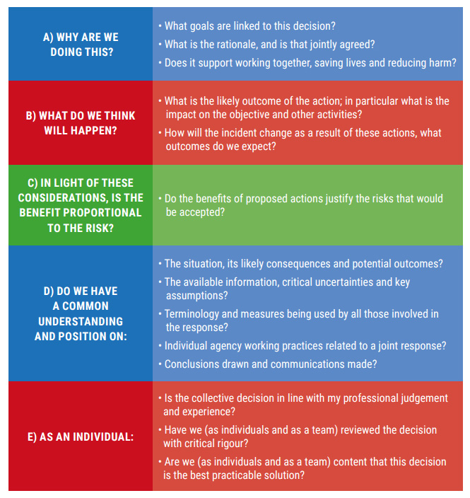

Incident Logs & Information Management
Minutes, or a 'Log of Decisions Taken', must be kept of all meetings of the CMT. It is also essential that individual members of the Group make their own notes of meetings. This will enable Officers to move forward on actions, without the need to wait formal actions/minutes to be issued.

Minutes, Logs of Decisions Taken and individual notes, should provide the detail of the continuing overall progress to respond to the incident. They will provide the context in which decisions on priorities can be made.

The CIT will manage a log of actions and should be provided with details of progress by Department Managers.

The Executive Officer will ensure that copies of the minutes/logs are made available to the CMT in a timely manner.

Communications Strategy
The Executive Director may request that Corporate Communications develop a communications strategy with regard to the incident.

Information should only be released to the media after consultation with Corporate Communications and on the authority of the Executive Director.

The communications strategy should include communication with the following stakeholders:
- Staff
- Partners/Stakeholders (e.g. OPFCC/Police/Local Authority/Unions/Government)
- Communities
- Media
For further information please refer to Appendix 5.

Managing the Response
The CMT will continue to manage the initial response to the event, until such time as business continuity has been implemented and is being delivered effectively.

Managing the response to the incident will require:
- A series of CMT meetings to drive the implementation of business continuity.
- CIT to track the progress to complete actions and resolve issues.
- CMT members to direct the business continuity response at the departmental level.

Welfare
Consideration must be given to the welfare of all officers (strategic, tactical and operational) responding to the incident. Working on the response to any incident can be very intense in the initial stages.

The following points should be considered:
- Subsistence of officers working on the incident.
- Limiting the working time of staff (consideration of 6 hours shifts).
- Setting up a rota and resting staff.
- The effective briefing and authority levels of deputising officers.

Recovery Issues
In the initial stages of an incident it is vital to consider the recovery process. The Chair of the CMT may choose to task a separate group to consider the issues of recovery, which can run in tandem and report to the CMT.

Once business continuity is in place and the organisation is again functioning, possibly at a reduced level. The Service will move from a state of response to the immediate impact of the incident, to longer term recovery from the event.

Formal Handover to Recovery Co-ordination
Once the initial phase of the incident has been concluded and Business Continuity arrangements are in place the CMT will hand over control of the incident to the Recovery Co-ordination Group (RCG).

This page has been left intentionally blank.

Section 4:
RECOVERY CO-ORDINATION

Content Page Number

4.1 Recovery 26
Introduction 26

4.2 Recovery Co-ordination Group 26
RCG Sub Groups 27

4.3 Stand Down 27

4.1 RECOVERY

Introduction
The nature and extent of the recovery process will depend upon the on the nature, scale and severity of the incident itself. The RCG will review/set the recovery strategy for the incident, which may require the Service to return to normality or return to a new normality.

The impact of the event could include:
- Loss, damage or denial of access to buildings and the subsequent displacement of staff.
- Failure of ICT services and/or loss of data.
- Serious injury and death to personnel.
- Staff suffering (including physical and psychological effects) and a general impact on morale.
- Financial impact on the organisation.
- Reputational damage.

4.2 RECOVERY CO-ORDINATION GROUP

The RCG will bring together the key departments involved (dependent on the incident) and will be led by an Executive Officer (appointed by the Executive Director).

The purpose of the RCG is to:
- Provide visible and strong leadership during the recovery phase.
- Establish recovery sub-groups, as appropriate to manage the incident (see below).
- Coordinate the recommendations and actions of the sub-groups, monitor progress and take advice.
- Decide final standard for recovery of physical infrastructure e.g. recovery to baseline, or opportunity for regeneration.
- Decide the overall recovery strategy around staff welfare, property; infrastructure; communication; financial and legal; and reputation.
- Ensure that relevant stakeholders are involved in developing and implementing the strategy
- Take measures to ensure the rebuilding of public confidence if appropriate.
- Ensure the coordination and delivery of consistent messages to the public and media.
- Monitor financial matters and pursue funding and other assistance.
The Chair of the RCG may decide to implement a structure of sub groups to deliver the work of the RCG. A suggested structure is detailed below, which can be tailored dependent on the nature and impact of the incident on the organisation.

The RCG and sub groups will meet regularly to drive the implementation of recovery processes.

RCG Sub Groups

Communications & Reputation Group
This Group will manage both the internal and external communications strategy. To ensure that staff are kept informed of developments and to protect the reputation of the Service internally and externally.

Property Group
Assess the impact on ECFRS property and manage the recovery process in line with the organisational strategy outlined by the RCG.

ICT Group
Ensures the recovery, restoration or rebuild of all ICT architecture and data.

Support Service Delivery Group
Will manage the recovery of support functions and manage the return to business as usual.

Finance & Legal Group
Assess the financial and legal implications of the incident on ECFRS, and to take steps to mitigate the impacts on the organisation.

Staff Health & Welfare
Assess the impact of the incident on staff welfare and ensure that processes are in place to support staff.

Response / Stations Group
Assess the impact of the incident on the response to communities and manage the recovery process.

4.3 STAND-DOWN

The Chair of the RCG, in consultation with other members and the Executive Director will decide when it is appropriate to stand-down the Group. The RCG will be closed once regular recovery co-ordination is no longer needed and remaining issues can be dealt with as a part of normal business. The length of time that the RCG is required to continue meeting will vary according to the nature and scale of the incident. The decision to stand-down the RCG will be formally communicated to all staff.

This page has been left intentionally blank.

Section 5:
ROLES & RESPONSIBILITIES

Content Page Number

Chair Crisis Management Team 30

Crisis Management Team Member 30

Departmental Managers 31

CMT Minute Taker 31

Chair - Crisis Management Team (Executive Director)
- Assess the impact of the event on the organisation and make the decision whether to declare a major business continuity incident.
- Invoke the Business Continuity and Recovery Strategy.
- Lead the organisation through the initial response to the event.
- Chair the Crisis Management Team Meetings, utilising the standard agenda.
- Implement departmental progress reporting via CIT.
- Approve the decision to move from Business Continuity to Recovery.
- Approve the decision to close the incident and return to business as usual.
- Ensure that a debrief of the incident is held, lessons are learnt and applied.

Crisis Management Team Member (SLT)
- Ensure the welfare and subsistence needs of their staff are met.
- Assess the impact of the event on the organisation, stakeholders, partners, communities and staff.
- Take mitigating actions to reduce the impact of the event on the Service.
- Attend CMT meetings.
- Lead the invocation of business continuity for the relevant service area.
- Highlight issues for the consideration by the CMT.
- Keep a log of all requests and actions.
- Allocate resources and approve tactical priorities.
- Participate in RCG meetings.

Departmental Managers
For the purposes of this plan Departmental Managers are the owners of the Departmental Business Continuity Plans.
- Assess the impact of the event on your department and the wider service, take mitigating actions to reduce the impact as appropriate.
- Implement your departmental BC Plan as requested.
- Ensure the welfare of staff.
- Keep staff informed.
- Highlight issues to the CMT or RCG.
- Manage the expectations of stakeholders.
- Provide reports on progress of the department with regard to the implementation of Business Continuity arrangements.

CMT Minute Taker

All CMT meetings should be recorded. Minutes shared with the CMT Members. The CMT Minute Taker should report to the CMT Chair, circulate agendas and documentation to CMT members as appropriate. The CMT Minute Taker should be a member of the Executive Support Team or an alternative officer with the experience of recording meetings.

This page has been left intentionally blank.

Section 6:
INCIDENT DEBRIEF

Content Page Number

6.1 Post Incident Actions 34
Structured Debrief 34
Debrief Report 34

6.1 POST INCIDENT ACTIONS

Structured Debrief
Following the closure of incident the Executive Director will set out the requirements for a debrief, in line with the Service’s debrief process.

The purpose of debriefing is to allow those involved in an event to communicate their experiences in order that lessons can be identified and recommendations made for future improvement to business continuity arrangements. In essence the debriefing process looks for answers to the following three questions:

- What did not go so well? How well prepared where we?
- What did go well? How well did we do?
- What should we do next time? What can we do better in future?
It is vital that the debriefing process is seen as an opportunity to learn from experiences to develop good practice. They should not be used as a method of apportioning blame for any failings identified.

All departments involved in the response and recovery process should consider internal debriefing following the incident. Lessons learnt can be incorporated into business continuity plans.

Debrief Report
A final debrief report will be produced. The report will be taken to SLT for identification and allocation of any further action required. SLT will own any recommendations and track progress as appropriate.

Section 7:
APPENDICES

Content Page Number

1. Actions Aide Memoire 36

2. Guidance for Crisis Management Team 39

3. Designated Relocation Sites (Loss of KP) 44
4. Recovery Priorities 45
5. Communications 46

APPENDIX 1

ACTIONS AIDE MEMOIRE

Time  Line | Actions | Objectives
1st Hour | Set up a command structure  “Golden Hour”  Response  Accuracy of information.  Rapidity of receipt of information. | - Activate evacuation plans, if necessary, and account for all staff.  - Invoke the Strategic Business Continuity and Recovery Plan.  - Invoke the Premises Plan.  - Identify individual managers to roles and responsibilities.  - Convene a Crisis Management Team/Critical Incident Team if necessary. (See possible Agenda below).  - Identify the ICP if necessary, and where the CMT/CIT will meet.  - Establish a (unified where necessary) command structure.  - Commence strategic risk assessments.  - Identify optimum Information Management & Communication chains, e.g. Managers Mailbox.  - Alert ERF Partners of Major Incident if necessary.  - Identify, and if necessary act on, use of secondary sites.  - Provide a SITREP/CRIP (See CMT/CIT Agenda) to Control.  - Communicate to all parts of the Service, (vertical and horizontal), particularly those staff not directly involved with incident management – maintain morale.
 | Gather and disseminate information  Establish a “battle rhythm” for dealing with the situation  Also see the CIT Agenda that follows. | - Is Control involved in the incident? If so, ensure that its Business Continuity Plan is under way.  - Seek to achieve an understanding of the overall picture in terms of its scale, duration, impact and interdependencies:  - Scale: How significant and widespread is it or might it become?  - Duration: How long it is likely to continue?  - Impact: How bad is it? How bad could it become?  - Interdependencies: These need to be identified in terms of what is happening, what may happen and what the consequences of a given decision might be.  - Assess the situation, and the current posture of the SHQ/Station/Premises. Widespread/Local?  - Consider contact with the Essex Civil Protection & Emergency Management team Duty Officer.  - Gain the best information available to enable the risk assessment and prioritisation of actions to take place.  - Determine the optimum direction of travel for initial response.
 | Assess the situation | - Maintain / establish a communications link between deployed resources, resources on standby, and command.  - Ensure that arrangements are in place to maintain/provide an operational response.  - Ensure that Departments have tried to contact staff at home, where and if necessary/possible.  - Ensure that ICT is available to facilitate Service requirements, ancillary functions and communications. If ICT is not available, urgently consider alternative means of communication.  - Prioritise the options available.
2-3 Hours | Continue assessing options & solutions | - Continue with information gathering by regular meetings at Directorate and Department managerial levels to confirm or redefine priorities and the optimum direction of travel on actions.  - Determine which specific departmental business continuity and recovery plans need to be invoked and identify those personnel, facilities and resources needed to execute those plans.  - Establish arrangements to achieve minimum numbers and key locations – establish what level of operational response we can provide and where that should be (re)located.  - Ensure communications regarding the incident are being passed in a timely and accurate way to all staff across the whole Service.  - Identify actions and resources that could assist in hastening the start of the recovery time or shortening the recovery time, or will prevent worsening the situation.
 | Strategic planning | - Communicate with any other responding agencies to establish a common aim and determine ECFRS role and responsibilities in achieving the aim.  - Consider informing the appropriate Government department(s).  - Execute the Media Plan, liaise with the Press and electronic Media, issue Press Releases as early as possible, and consider holding a Press Conference.
 | Conduct tactical planning to reduce or mitigate impacts of event | - Prioritise which tasks should be dealt with first, and where resources should be allocated.  - If ICT has been disrupted, prioritise which ICT systems are required to deal with the given scenario and which can be sacrificed in the short term (ICT DR Plan).
4-5 Hours | Prioritise resources & tasks | - Obtain specialist advice as required.  - Determine actions in relation to the Media: automated responses, press interviews, GNNC etc.  - Look at HR requirements along with accommodation and equipment to ensure sufficiency.  - Consider shift systems for all uniformed and non-uniformed (HQ) staff including staff welfare issues on site.
6-24 Hours | Completing tasks initiated earlier | - Put in place the communications policy.
 | Begin consolidating | - Participate in an external interagency or regional command structure if necessary.  - Continue with managerial level(s) progress review meetings at a frequency that meets needs.  - If not already achieved, and if possible, move from reactive to proactive actions, combining recovery with response as soon as practicable.  - Initiate welfare and relief arrangements for all personnel (off duty rotas, psychosocial support, etc.).  - Salvage / Re-occupancy options?
 | Reviewing progress against plans and actions | - Identify Second XI / Third XI managers for relief.  - Identify critical staff and make provisions for their relief’s.
 | Predicted future needs | - Set objectives for 2 days and 7 days hence (rolling programme); put arrangements in place to achieve the objectives set.

APPENDIX 2

GUIDANCE FOR CRISIS MANAGEMENT TEAM

The following table provides guidance and direction for action for the CMT as the trigger incident passes and the business interruption event progresses.

Chairing the Group | The Chair be the Executive Director or will be the most appropriate level of officer to deal with the matter at hand as nominated by the Executive Director. It will be dependant on type and stage, and the potential subsequent events. Consider the need for a Crisis Management Team or a Critical Incident Team. Account for long-term consistency.  The Executive Support will provide the secretariat function or CIT function to record meetings and circulate Minutes BEFORE the next meeting.
Membership. | Emergency response and recovery requires the attention of top-level management. The CMT/CIT must comprise representatives with the appropriate mix of seniority and authority in order to be effective.  An incident involving a major interruption to KP will almost certainly require representation from Finance, Purchase and Supply, Property Services and ICT, amongst others.  Consideration must be given to:  - Are the necessary and appropriate Departments represented? (This may change considerably as the trigger incident and the subsequent event progresses and should be subject to continuous review).  - What are the areas of expertise and responsibility of those persons present?  - Are the most appropriate persons present from the represented departments?  - Representative Bodies attending?  - CMT/CIT meetings should be kept to a minimum number to maintain focus and effectiveness. The Chair should consider the attendance of the Incident Commander (in the short term and only if it necessary and appropriate, and does not jeopardise or compromise the effective running of the incident ground) to give an accurate sit-rep. It is also highly recommended that a Service media representative is present.
Situational Awareness (To aid decision making)  This provides the basis of a SITREP or COMMON  RECOGNISED  INFORMATION PICTURE  (CRIP) | - What happened? (Departmental SITREPS).  - What is the estimated duration of the incident?  - Who and what is impacted, (directly & indirectly)?  - What impacts can be minimised and how?  - What has changed?  - What is happening now?  - Which plan(s) do we need to invoke, and when, if not already open?  - Who is available to execute those plans?  - What resources do they need?  - If required, where are further resources available from?  - What progress is being made on executing those plans?  - What roadblocks and hurdles stand in the way of response and recovery?  - What, if any, interdependencies can we identify now, or possibly foresee later?  - What is the wider community impact – Health, economy, environment, utilities?  - What is changing, or is likely to change shortly?  - What can be foreseen and avoided?  - So what?  - What might happen/go wrong? Law of Unforeseen Consequences?  - How bad is this? How bad could it become?  Factors  P Political E Economic or financial S Social T Technical E Environmental  E Ethical L Legal or regulatory O Organisational
Immediate  Risk Management | In emergencies, risk becomes dynamic. New risks emerge, previously recognised risks recede and the balance between risks changes continuously. Active risk assessment and management should be an ongoing process. It should also enable, rather than obstruct, effective operations by providing analysis of, and solutions to, anticipated problems before they arise.  - Incident Risk (OIC).  - Service Delivery Risk.  - HR Risk.  - Reputational Risk.  - Financial Risk including Contractual Risk and Insurance arrangements  - Political Risk.  - Legal Risk (Inc H & S Risk and other compliance/regulatory issues & see below).  Subject to the nature of the incident, a fuller risk assessment may be necessary.
Setting the Direction (Formulation of Strategy). | The CMT strategy is to determine and promulgate a clear strategic aim and objectives and review them regularly, not Departmental strategies. A strategy must be capable of translation at the operational level, without ambiguity, or lack of clarity. Any policy frameworks must be accurately recorded and transparent.  Establish a reporting regime and a battle rhythm for crisis management.
Resource Requirements. | People  - Are there any deaths or (serious) injuries?  - Are staff to be sent home or relocated to a different site? (Short/medium term?)  - Do staff need immediate welfare/counselling?  - How are we communicating with staff/public/partners/stakeholders?  Facilities  - Is the building secure?  - Are sensitive/classified areas secured?  - Has a preliminary damage assessment of facilities been arranged?  - Has salvage been arranged? (If safe to do so).  Technology inc telecommunications  - Has preliminary damage assessment of technology / telecommunications been arranged?  - Has the ICT Disaster Recovery Plan been activated? (Yes – So what? No – what’s working?)  - Are phone diversions activated (if possible/necessary)?  Vital records  - Has a preliminary damage assessment for vital records been arranged?  - Are sensitive/classified documents secured?  Identify resource providers.  Make early decisions in relation to financial considerations.
Health and Safety. | Ensure adequate Risk Assessments are being recorded in relation to the scene activities, and shared.  Ensure that Health and Safety at Work Regulations are properly adhered to.  (N.B. Responding to a major incident will not have a lessening of impact on statutory responsibilities. Even greater considerations maybe required, with higher levels of risk assessment, expense and effort.[UK Health and Safety Executive, 2006])
Identification of Deceased. | Death in the Workplace Policy.
Investigation. | Ensure that recognition is given to the fact that any major incident will attract the probability of a multi-faceted investigative process both in the numbers of organisations involved and the type of subsequent inquiry (e.g. Fire, Crime, HSE, Rep Bodies, Air/Marine/Rail Accident Investigators, and Military).  Many major incidents result in Public Inquiries and can have extreme implications for the investigators and those investigated (e.g. Hillsborough).  Give appropriate weight to consideration of possible litigation. Seek the involvement of Legal Support representatives at a very early stage in the proceedings. Consider evidence gathering/preservation of evidence.
Media. | It is imperative to formulate and implement media-handling and public communication plans quickly.  Consideration must be given to:  - Agreeing who will be the lead agency for media in any multi-agency incident.  - Ensuring press releases are co-ordinated and delivered by the right people.  - making appropriate use of any additional public communication medium,  - Establishing a media centre.
Government Liaison and VIP Visits. | Consider:  - Who can be expected to attend either HQ or the scene? (e.g. which lead Department Minister)  - Should the CMT initiate the contact with the Home Office?  - Is a team needed to deal with VIP visits?  - Role of OPFCC
Recovery | Managing the Recovery phase is as important as responding to the trigger incident. Planning for Recovery should start as near to the beginning of incident management as possible. It may need a separate team to work on recovery concurrently with incident response. This will depend on the nature of the incident, typically around the extent of damage involved. In any event, Response and Recovery must work together.
Insurance. | Recognise that insurance companies will have a part to play in the recovery process and they should be involved at an early stage. They will, however, require careful management and control. Consideration must be given to the timing of getting their representatives into the area.
Stress Management and Debriefing. | This is essential to the long term resilience of the response and beyond.  Ensure:  - Welfare departments are properly and thoroughly engaged in the process from a very early stage.

APPENDIX 3

DESIGNATED RELOCATION SITES (Loss of Kelvedon Park)

The following identifies the location of the HQ departments’ alternative sites that would be utilised following the loss of Kelvedon Park. All departmental plans detail these locations. These locations will not accommodate all staff from each department. This will mean that all departments at KP have somewhere to go with space and equipment to enable them to continue their critical functions.

Stations have loss of site arrangements, which are included in station business continuity plans.

The following alternative sites are for short to medium term occupation only, and will serve until firm arrangements are in hand for the medium to long term.

Department | Alternative Location
Health & Safety | Braintree
Performance & Data Management | Tiptree.
HR x 5 | STC.
L&D x 5 | STC.
Operational Training | STC
Safer Communities | Coggeshall.
Technical Fire Safety | Work from home.
Operations | USAR.
Executive Support | Rayleigh Weir.
Control | Ongar.
Finance (Pay) | Billericay.
Finance Other | Work from home.
ICT | Harlow for DR.
Communications & Media | CMT/CIT at Rayleigh Weir or Orsett.
Technical | Lexden W/S.
Property Services | Ingatestone
Emergency Planning | Rayleigh Weir.
Risk & Business Continuity | Rayleigh Weir.
Occupational Health | Dynamic arrangements on the day.

APPENDIX 4

Recovery Priorities

Stations have loss of site arrangements, which are included in station business continuity plans.

The following alternative sites are for short to medium term occupation only, and will serve until firm arrangements are in hand for the medium to long term.

Department | Recovery Priority
Control | 1
Fleet Services | 1
ICT | 1
Property Services | 1
HR & OD | 2
Communications | 2
Purchase & Supply | 2
Performance Management | 2
Operations | 3
Technical Services | 3
Finance & Pay | 3
Safer Communities | 3
Executive Support | 3
Water Services | 4
EFA Trading | 4
Technical Fire Safety | 4
Health & Safety | 4
Emergency Planning | 4
Occupational Health | 4
Learning & Development | 5
EFA Trading – Vehicle Sales | 5

APPENDIX 5

COMMUNICATIONS

Good communications will be vital to any coordinated response during a major business interruption. This includes external communications, particularly if the public and media perception is that the Service may fail at some point, however briefly. The term “Communications” covers a multitude of activities and, in this instance, covers communicating with people in the close and wider community with whom the Service needs to make contact with, and engage, during an incident.

Communications need to be set up immediately for incoming and outgoing calls for: -
- The public.
- Staff off-duty.
- Staff at operational locations (HQ/Community Commands/Stations etc).
- External organisations.
- Critical Incident Team.
- Print and Broadcast (News) Media.
- Elected Members of the Fire Authority.
- Emergency Services Co-ordination.

Media and Information Management during any major business interruption will be important. Such an event is likely to attract considerable media attention, and to a scale that will demand management and expertise to avoid negative press and unwanted attention. Subject to the nature of the event, journalists and photographers can be expected within minutes of an incident occurring. It is therefore necessary to make arrangements for the needs of the media, who must accept the need for some control of their activities when appropriate.

The needs of the media are best served by the provision of a single source of information and this can be provided by one of two methods dependent upon the type of emergency: -

For incidents involving ECFRS as the lead agency, then the Corporate Communications, Media and Marketing team via its 24/7 dedicated press line and incident database will be the sole point of contact. Where other emergency services are directly involved, or where Silver or Gold Command operates, press releases will be generated and channelled through the Police Public Relations Officer at Police Headquarters, Chelmsford in line with an established ‘blue lights protocol’. This will ensure a "united front".

In the event of there being no service available through the Police, regular press statements will be provided by the *Corporate Communications team operating from anywhere in the County as appropriate. All press releases must be sanctioned by the appropriate Executive Officer or his nominated deputy prior to their release.

*The Corporate Communications Officer holds details of all media contacts and decide in consultation with the appropriate Executive Officer or his nominated deputy the 'stance' the Service will take.

Only Senior Managers and media trained flexi-officers are authorised to make factual statements to the Press on their own activities or those of their Department but they must not express opinions, or comment on the work of others connected with the emergency in any circumstances, unless they have been authorised so to do.

Experience has shown that local radio stations can perform a most valuable role during an emergency and provide an information service for the public. The Service will make full use of such facilities not only to pass information to those affected by the emergency, giving advice, guidance, and explaining the role of the Service, but also to obtain information to identify resources and potential assistance. Monitoring broadcasts and maintaining close liaison with local radio will provide useful information on the extent of the effects of the emergency.

Press officers have been designated for dealing with the media both at an operational incident and remotely. Press will not be permitted to enter any operational centre, e.g. Control unless accompanied by a press officer and with the explicit approval of the incident commander.

CO-ORDINATION AND INFORMATION

There is likely to be a heavy demand for information from both the media and the public during a major incident involving the Service. Even a minor incident could generate a substantial number of enquiries to the Service, involving the issue of regular press statements:

- Public alarm is not caused.
- Undue stress is not caused to casualties or their relatives and friends.
- The public are discouraged from ‘sight-seeing’ at the scene.
- Reliable information is given to the public.
- The needs of the news media are met and their skills and resources are used to the best effect.
- Allowances are made for the fact that each organisation involved wishes to keep its members informed.

Media communications will be dealt through the Corporate Communications, Media & Marketing Department. During an incident, this Department will provide dedicated press officers – one in the office, one at the scene and a photographer - to be available at all times for response to enquiries from the media. The Corporate Communications Officer will work closely with the appropriate Executive Officer or his nominated deputy (and the Police) to ensure the Service is able to respond adequately to all media enquiries.

BRIEFINGS

It is important for all staff to be kept informed of developments during an incident. This will reduce the spread of misinformation and help staff not directly involved in the response to understand what absent colleagues are doing, and why it is important for them to try to maintain normal services.

Arrangements for briefing OPFCC will be made by a principal officer regarding:

INTERNET & INTRANET

The Internet and the Intranet will both be used as information platforms, in addition to any other means of internal and external communications. This may include Facebook and Twitter. The Service website will be updated on a regular basis and the address included in all Press Releases.

[END]

This could be due to flu pandemic (please refer to Loss of People Plan)
See Declaring a Major Incident 1.3
See Section 2.

