ESSEX POLICE, FIRE AND CRIME COMMISSIONER FIRE & RESCUE AUTHORITY
Essex County Fire & Rescue Service
Meeting | Performance & Resources Board | Agenda Item | 7
Meeting Date | 24 September 2018 | Report Number
Report Author: | ACFO IRMP and Service Improvement
Presented By | ACFO IRMP and Service Improvement
Subject | ESMCP
Type of Report: | Approval/Information

Recommendations
- That the Performance & Resources Board note the decision made by SLT in respect of the ECFRS ESN Adoption Strategy paper (Appendix C); which was to recommend that:
In the immediate term, agree that Option A (ESN Direct v.3 and Connect Adoption 12/2019 (Voice & Data)) is the preferred approach for planning purposes, for the following reasons: -
  - This option, although committing resources now, affords the most flexibility and allows department planning to commence in preperation for the next budget cycle.
  - This option affords the most agility in decision making at a later date when other factors, although identified, are yet to be quantified and reported.
  - This option serves as a responsible working assumption, but doesn’t preclude a decision to choose a preferred alternative option when/if further information becomes apparent.

BACKGROUND -
- Timeline of Emergency Services Mobile Communications Programme (ESMCP) 2018 events:

- January ’18 - The National ESMCP Team determined that the current delivery strategy was unlikely to deliver within previously agreed tolerances for both time and budget. In addition, Motorola Solutions Incorporated (MSI) had informed the programme that they might struggle to deliver some requirements in full and others within a timeframe that users may consider as acceptable.
- March ’18 – An independent team was formed to review and reset ESMCP activity, and to consider four pathway options (see Appendix A). A new Programme Director, Bryan Clark, was appointed.
- April ’18 – Analysis of the four options identified that options B and D were both viable, with Option B being the preferred option. The Programme Director met with the Permanent Home Office Secretary seeking approval to continue the evaluation of the two options. This approval was granted with both parties agreeing that whilst it was responsible to consider both options, Option B was the preferred option and significant effort should be invested in defining this delivery approach.
- May ’18 – Option B is identified as a Change Programme focussing on customer adoption of ESN Products rather than a centre led technology driven implementation. Customer engagement is initiated requesting each Service (customer) to indicate their level of support for this approach and an early indication of appetite towards each ESN Product. Each Emergency Service Sector is also asked to consider Option D, and specifically, their preference between Options B and D.
- June ’18 – The three Emergency Services make a joint submission of their assessment of the two options (See Appendix B); whilst the content of the report implies that Option B is preferred, the report falls deliberately short of making a recommendation.
- July ’18 – The Home Secretary endorses the ESMCP Director’s recommendation that Programme activity continues with the working assumption that Option B is the preferred approach whilst acknowledging that Option D, although not preferred, remains viable and will be included as part of the revision of the Full Business Case (due Dec ’18).
- August ‘18 ECFRS Activity – Our internal COSMOS (Communication Systems, Mobilising and Operational Solutions) Programme has defined our own roadmap to ESN adoption (off-boarding from Airwave) options, with a paper (see Appendix C) presented to SLT on the 19th September in which the recommendation was supported.

Benefits and Risk Implications
- See Appendix C Options and Analysis
FINANCIAL IMPLICATION
- Whilst there are no immediate financial implications to be considered as a result of endorsing the recommendation, it should be noted that further information is being sought from the National Programme on a number of matters which may yet influence our direction of travel, chief of which will be the financial arrangement by which the provision of Airwave is made available to Fire & Rescue Services’.

Equality and Diversity Implications
- No equality and diversity implications have been identified at this stage

Workforce Engagement
- Initial workforce engagement to date has included all COSMOS Board personnel, which includes representation from the Collaboration Team.

Legal Implications
- There are no legal implications to consider at this stage.

APPENDIX A

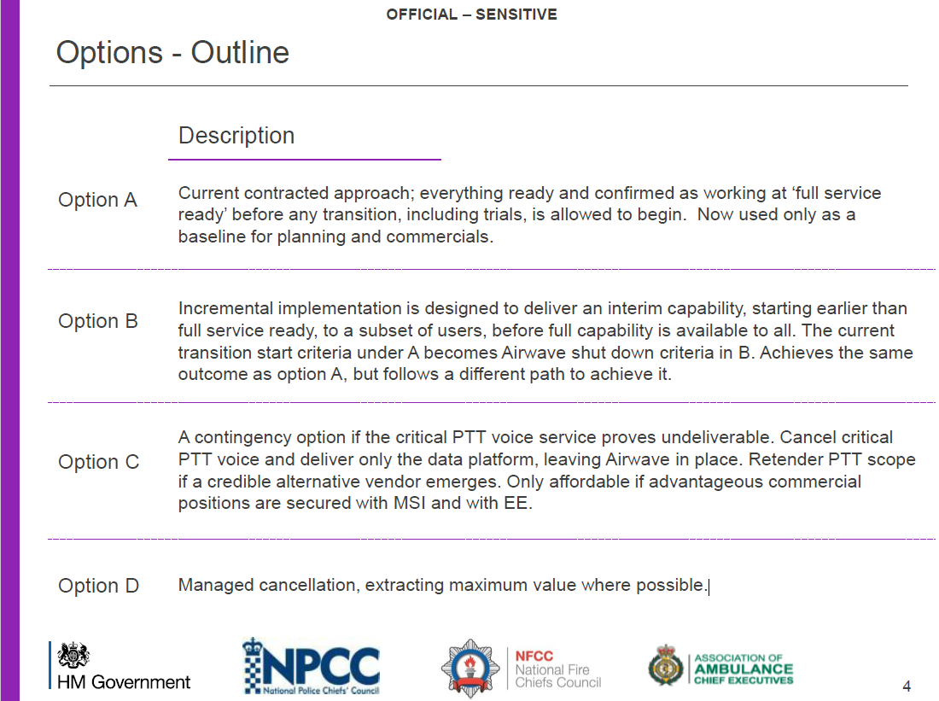

APPENDIX B
Joint Submission for the Permanent Secretary
Emergency Services Mobile Communications Programme (ESMCP)

Opening

This submission has been developed, in full collaboration, by the emergency services who are detailed at the end of the report and represents an agreed, and joint, response.

Intention

The intention is to provide a broad overview of how emergency services assess a change in programme delivery direction, from the initial plan (referred to as Plan A), to either a more incremental approach (referred to as Plan B) or the pausing/shutdown of ESMCP (referred to as Plan D).

Assumptions

- The national programme (Authority) has concluded the current approach for ESMCP delivery (Plan A) is now not tenable and are seeking to alter the approach to national ESMCP delivery.
- User organisations are being asked for a view as to whether Incremental (Plan B) is a methodology for delivery, which user organisations believe is viable and an approach they can support.
- To consider what the potential risks/issues/benefits could be should the programme be paused or cease (Plan D).
- Due to timescales, and the current lack of detailed information, this view has been predicated on best endeavour and will only comment on viability and will not be advocating, or recommending, any direction or approach.
- The strategic ESMCP endeavour remains the delivery of the next generation of communication systems for the emergency services. This includes the full replacement of an aging, predominantly voiced based, critical communications system along with the delivery of a universal, secure and resilient mobile broadband platform enabling modernisation and transformation across the emergency services.
- Any decision regards the future of ESMCP is, and remains, the preserve of Government.

Context

To date the emergency services have worked hard in supporting the development of a resilient communications system to replace the current Airwave system, whose contracts fully end in December 2019.

The Emergency Services rely on the availability of an effective and resilient mission critical communications infrastructure and system to support both emergency and daily activities. They use a combination of critical voice and basic critical data communication to deliver public service to their communities and staff. Additionally, where technology allows, greater use is being made of high speed data access in support of service improvements.

It is acknowledged, due to services ever expanding digital footprint and services, the current Airwave solution does not meet new, and ever-increasing demand, for access to evolving and enabling technology now being used by the general public and private sector.

Perspective on Incremental Programme Delivery (Plan B)

Anticipated Benefits
- The incremental (agile) approach to delivery is a common methodology applied to ```complex change and IT programmes
- Emergency services are highly motivated to support any method for delivery, which can effectively, safely and quickly transition to full ESN capability and feel they are able, and prepared, to work in a much more agile way to support such an approach
- The dawning ‘customer centric’ approach to national programme delivery is welcomed and applauded by emergency services and they look forward to a truly collegiate ‘joint endeavour’ going forward. This approach is already beginning to positively manifest
- An Incremental (product based) approach can offer significant benefit, especially in terms of;
- Provides an opportunity to validate/test/trial and assure capability and technology within a low risk environment.
- Undertake iterative development of this technology/capability to ensure adaptations/fault fixing etc. can be undertaken prior to the full solution being finalised.
- Allows business change to occur concurrently, and in concert with, individual service digital, IT roadmaps and budgets.
- Allows early adoption of capability should it accord with organisations technical and financial appetite.
- Ensures a credible, sustainable and operationally acceptable full critical communication solution is available prior to Airwave shutdown.
- While acknowledging an incremental approach could produce viable technology and capability for integration into business as usual environments, this will have to be predicated on individual service capability, and willingness, to undertake the cost/benefit assessed business change required to support it.
- In essence, there are two key stepping stones to full transition, those being, full Mobile Network Operator (MNO) capability followed by full final solution becoming available. The pathways to this (increments), however, present significant opportunity to design and mobilise, leading to a far more effective and accelerated transition.
- All agree transition, at the earliest opportunity, to full ESN functionality and the shut down of Airwave should be the main programme focus due to the significant economic and technical benefits identified at the outset of this programme.

Issues for consideration
As this approach is still in a formative stage, there are many significant issues/elements, which require exploration and clarification. For this reason, much of the perspective provided here is predicated on an assessment of methodology rather than a detailed cost/benefit analysis based upon a credible and costed business case and plan. As such, with an incremental approach we have to ensure there is due diligence and agreement regards the following areas going forward;
- Accountability/Risk ownership
- Cost and contractual understanding/definition
- Validation, test, trial, pilot and acceptance criteria
- Technical capability
- Ensure sustainable ways of working and collaborative endeavour.

Note: A much more detailed analysis of this proposed approach is being prepared for the programme to consider, and work through, with the emergency services.

Pause/Stop the Programme (Plan D)

Benefit
- Allow the technology, and supplier capability, to catch up with the ambition of adopting this solution. However, the emergence of Kodiak, suggests technology and supplier gaps may be less challenging than recently thought.
- Allow more time for the current network infrastructure to be developed and fully tested.
- Provide a defined position on which to understand the resilience, and sustainability, requirements of the Airwave solution.
- Provide organisations with more time to plan their digital, IT and Airwave strategies in a more defined way.
- Generate a more stable picture in the immediate term, enabling the development of more accurate medium term financial plans. This could, however, be at the expense of longer term planning.

Risk
- Emergency services are now fully integrated into, and reliant upon, the digital environment. Airwave technology does not support this evolution and will begin to inhibit integrated systems, business processes and modernisation going forward.
- The lack of a plan for an integrated national digital Mission Critical Communications Platform for the emergency services would be a significant lost opportunity against a backdrop of a sharp incline on adoption of fast moving mobile technology by the general public, private sector and crucially terrorists, organised crime and cyber crime perpetrators
- The Airwave infrastructure, and capability, is time limited and work on a credible future solution would have to start now.
- The knowledge base and skills set, generated to this date will dissipate, meaning significant ‘re-learning’ will need to take place.
- Current sunk costs and contractual requirements represent significant investment, therefore, the benefits which this could deliver may be lost.
- The supplier marker may consider its position in relation to future government contracts and programmes, potentially with reduced participation levels.
- Concerns exist that a long-term extension to Airwave could lead to significant legal challenge, which could be costly and also restrict work on sustaining the current service.
- Reputational damage could be created for sponsoring departments and governments, which could compromise the necessary future development of modern critical communications systems for the emergency services.
- If this programme ceases services should not lose the opportunity to make use of widely available efficient digital platforms. Therefore, current activity e.g. Air to ground, extended coverage etc. would need to continue, as drivers would still exist to mature the digital network ubiquitously across the UK.
- Service and public perception may generate significant cynicism regards future programmes of this nature.

Conclusion
While this report details an initial synopsis of Plans B and D, due to timescales and available information, it has had to be predicated on best endeavour and, therefore, only represents an initial view.

Local impacts on the viability of both options can only be fully matured when the dependencies, deliverables, technical implications and full costs are understood, and populated, into local business cases. Therefore, decisions in terms of full acceptance will have to be generated through the normal governance arrangements for each service in England, Wales and Scotland. Each organisation is an autonomous authority in its own right with Police and Crime Commissioners, Chief Constables, Fire Authority, Fire and Rescue Service or Ambulance Trust and the Scottish Services, ensuring their individual organisation performs efficiently and in the best interest of the public and community it serves. Indeed, in many cases it is this authority who has to deliver the statutory duties placed upon them.

The Emergency Services look forward to continued engagement and further contributions on critical communications development once Government has determined the direction of travel regards ESMCP.

This document reflects the collaborative and shared position of the below signatories;

Organisation | Signatories
National Police Service | OCiP Executive  DCC Richard Morris  Dr Stuart Lander  C/Supt Damien Smethurst  Mr Ian Whitehouse  Supt Lynne McCartney
National Fire Chiefs Council | Ian Taylor  ACFO  ESMCP Business Change Lead
Scottish Strategic Group | Jim Bilsland  ESMCP Business Change Lead
Joint Emergency Service Group (Wales) | Michelle Williams  ESMCP Business Change Lead
[Association of Ambulance Chief Executives] | Ian Hough  ESMCP Business Change Lead

APPENDIX C
