Performance and Resources Scrutiny Programme 2017/18

Report to: the Office of the Police, Fire and Crime Commissioner for Essex

Title of Report: | Crystallise Pilot Project in North LPA
Agenda Number | 3
Chief Officer | Victoria Harrington
Date Paper was Written | 11th August 2018
Version Number | V3.
Report from: | Essex Police
Date of Meeting: | 30th August 2018
Author on behalf of Chief Officer: | Chief Superintendent Ewen Wilson
Date of Approval: | 15th August 2018

- Purpose of Report

The purpose of this report is to provide an overview briefing to the OPFCC regarding the project to trial the Crystallise methodology in North LPA.

The report will outline how the project will inform the Force’s Digital programme going forward.

- Recommendations

This paper is for noting only.

- Executive Summary

The Crystallise programme was funded through the Police Reform and Transformation programme. It was a proof of concept project that sought to develop a methodology by which police forces could assess their current position in relation to digital policing and scope their respective target operating model.

Crystallise allowed forces to understand their unique ‘digital’ problems and develop and maintain local solutions.

North LPA in Essex was the pilot site chosen to test the model and involve frontline staff in scoping solutions to their challenges and in doing so become more effective and efficient in delivering their services to the public.

As a result of this work some 15 work streams were identified some of which remain on-going at the time of writing this report. Fig 6 below outlines the work streams.

The national funded Crystallise programme ended in March 2018 and final reports have been submitted to the National DII Programme Board.

Progress in the North LPA against the pilot project is managed through a Local Crystallise Steering Group chaired by Chief Superintendent Wilson. The programme of work is anticipated to run until December 2018 as some of the 15 work streams remain ongoing largely due to either business cases for change being considered or inter-dependencies with the Essex/Kent Police IT programme.

In December 2018 any remaining work will be absorbed into the programme to deliver the Essex and Kent Digital Strategy 2018-21. The strategy is currently in draft for Chief Officer’s consideration.

Close liaison is maintained with the National DII Programme (SRO DCC Michelle Dunn - Herfordshire Police) in order to ensure synergy and consistency with the national work.

4.0 Introduction/Background

Crystallise was a proof of concept project funded by the Police Reform and Transformation Fund (£1.5m). Its purpose was to develop a model that supports local policing in responding to crimes with a digital element and to develop how forces can better use technology to reduce and solve crime.

Crystallise as a programme received governance through The Capabilities Management Group chaired by Chief Constable Kavanagh. Within the group there were three work streams as follows:

- Digital Investigation and Intelligence (DII) Programme – mission to enable policing to protect the public through preventing and detecting crime in a digital age.
- Digital Contact Programme – Public able to feel informed, receive help, and complete tasks.
- Digital First Programme – sharing digital evidence across the criminal justice system.

Crystallise worked to the DII Programme with Gloucestershire, Durham and Essex collaborating to develop the target operating model (TOM).

It is broadly accepted that every crime has a digital element. Crystallise was commissioned to determine if the concept of an operating reference model to support the delivery of digital policing at a local level was feasible. In addition, it explored whether such a model could aid forces in developing digital policing locally and whether this had utility in the broader transformation of digital policing.

The essence of the Crystallise programme was to deliver dynamic user-driven solutions through the use of a structure, tools, and techniques to evidence the case for, and, to enable change.

The Crystallise Local Operating Reference Model (LORM) is designed to allow every Force to undertake their own unique digital policing transformation. The LORM provides a framework of digital services, capabilities and components depicted in Figure 1.

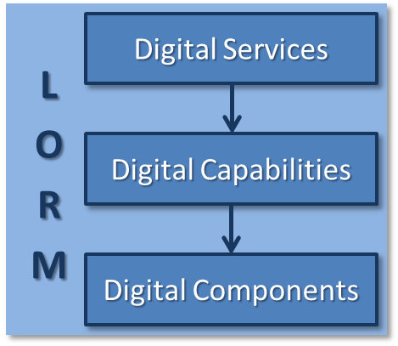
Fig 1: Crystallise Local Operating Reference Model (LORM)

The top layer consists of six strategic services which provide end-to-end whole systems approach to digital policing. Each service relates to a number of digital policing capabilities which, when taken together, represent an end-to-end view of digital policing at the operational level.

The capabilities represent numerous operational digital policing components - the discrete activities that need to be undertaken in order to deliver the services. Whilst the services and capabilities within the reference model are consistent, individual components are not. The components must be updated continuously as new technologies and capabilities emerge. The Crystallise model was built with sustainability at its core.

Each service addresses a specific strategic element of digital policing. The services are designed to provide a view of a force’s digital maturity and a structure for force leadership teams to discuss the most appropriate areas for further development and investment.
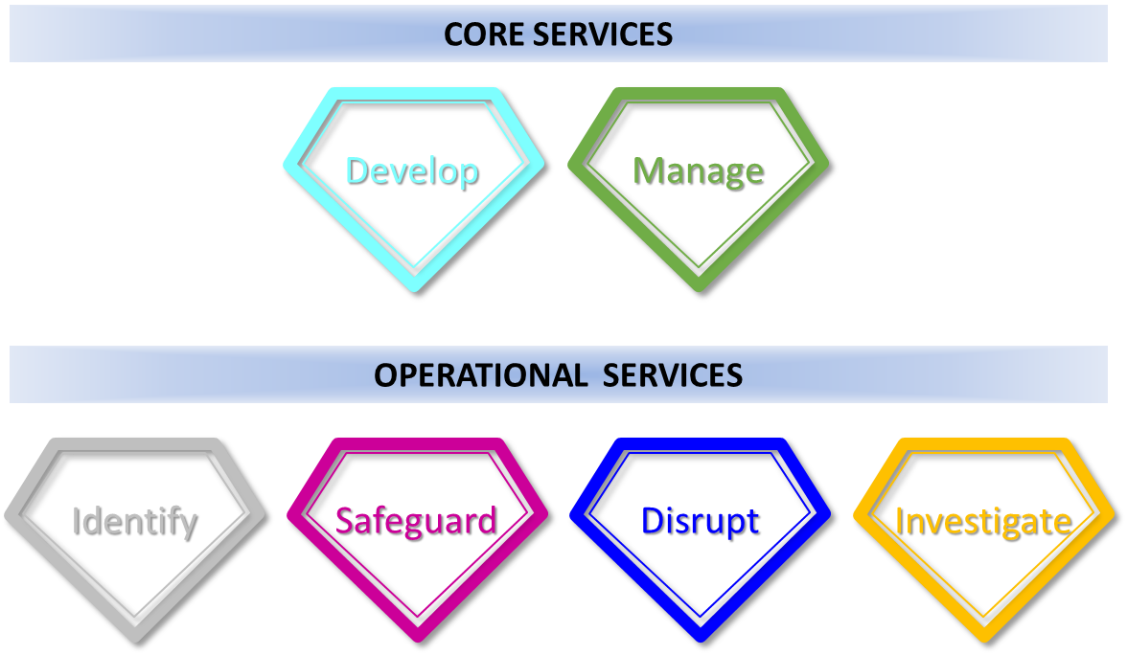
Fig 2: Digital Services

The outline below describes the Digital Services in more detail.
- Digital Develop – Setting the direction and continuous improvement of a constabulary’s DII capabilities
- Digital Manage – Manage the DII capabilities to meet the required benefits and performance of a constabulary
- Digital Identify – Obtain or examine digital data, information and intelligence
- Digital Investigate – Systematic examination of DII information in relation to incidents, crimes, or calls for service
- Digital Safeguard – Use of DII capabilities to safeguard the vulnerable
- Digital Disrupt – Use of DII capabilities to disrupt offenders
Fig 3: Description of Digital Services

Individually the capabilities represent numerous digital policing components. These components provide a working-level view of the elements of each capability. This is the detailed level that a Force needs to work at to understand and evaluate their current position and define change.

Whilst every Force will have elements of every service and capability, a Force will not necessarily possess, or need to possess all components within those capabilities. Additionally there is no one size fits all - each component may be achieved or implemented in different ways in each Force.

Each Component has an outline description and is measured in terms of maturity. Drawing on industry best-practice, Crystallise developed a maturity model to assess this using a 5 point scale:

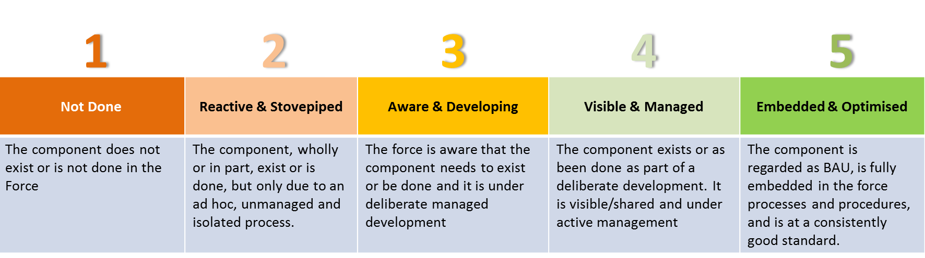

Fig 4: Maturity Model 5 Point Scale

Each component is also supported by a Component Development Guide, which is intended to provide the information a Force will need, including an evidence-base, to make decisions and plan and implement change.

The Model went through several cycles of development and internal validation before being finalised, demonstrated and endorsed at the Crystallise Symposium in September 2017.

North LPA Pilot

North LPA volunteered to be the national pilot and test the Crystallise methodology and tools.

The LPA is a significant geographic area with ever increasing demand against its policing resources. There was absolute commitment from the senior leadership team to test the model with a view to making officers and police staff more efficient and effective in providing policing services to the public across North Essex.

It was decided by the senior command to concentrate effort on key Force priorities, namely, domestic abuse, burglary, gangs, child sexual exploitation, and modern slavery.

Focus groups were held involving staff engaged in addressing these priorities. These groups worked their way through guided and facilitated discussion using the Crystallise model.

As a result 15 work streams were identified covering the high level service areas and representing the Target Operating Model (TOM) for North LPA.

The various stages of the North LPA pilot are summarised as follows:

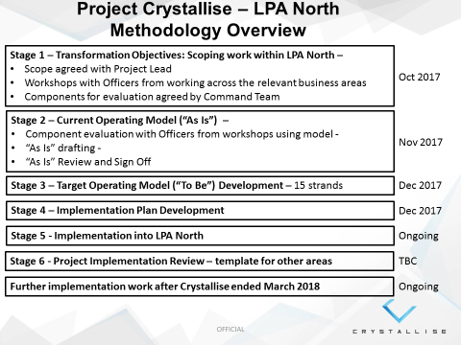
Fig 5: North LPA Methodology

A local Crystallise Steering Group chaired by Chief Superintendent Wilson has managed progress against the 15 identified work streams following development of the Target Operating Model (TOM) for North LPA.

A number of the work streams have obvious benefits for the Force as a whole. Where this is the case consideration for roll out for the benefit of the wider Force has been considered.

Identified Benefits of Crystallise

- It has described the LPA North position in responding to our priority crimes with a digital element and how technology and analysis is currently utilised to deliver policing services – this was a very useful exercise
- Most importantly it engaged frontline staff in this exercise – they were scoping the solutions and not passive recipients.
- It has provided a plan to manage the ‘as is’ transition to ‘can be’
- Raised awareness and understanding of the digital aspects of crime, this is helping to develop a change in culture where staff are minded around the benefits and challenges of the digital element of their work
- Made better use of the skills and technology already available within the force
- The programme supported the purchase of a small amount of additional technology to help staff be more efficient.

- Current Work and Performance

The figure below describes the 15 work streams mapped against the various digital services and components.

No. | Work Stream Description | Digital Service/Capability/Component | Completion/Ongoing | OPFCC Priority
1 | Digital Week | Manage – skills/knowledge | Completed | 1,3,4,5,6
2 | Interactive Knowledge Cafes | Manage – skills/knowledge | Completed | 1,3,4,5,6
3 | Immersive learning through virtual reality technology | Manage – skills/knowledge | Completed | 1,3,4,5,6
4 | Development of a knowledge hub and Digital Passport | Manage – skills/knowledge | Ongoing | 1,3,4,5,6
5 | Training for probationary officers on Digital | Manage – skills/knowledge | Ongoing | 1,3,4,5,6
6 | Mandatory skills training for all officers | Manage – skills/knowledge | Ongoing | 1,3,4,5,6
7 | Improved public access for submission of imagery and audio evidence | Identify – Public submission | Ongoing (preferred solution is DAMS) | 1,2,3,4,5,6,7
8 | Improved officer collection and viewing of imagery | Identify – Officer viewing access | Ongoing (preferred solution is DAMS) | 1,2,3,4,5,6,7
9 | Detective capability to take evidential photographs at scenes | Identify – Police personal mobile device | Completed | 1,3,4,5,6
10 | Introduction of transcription software | Identify – Police overt digital audio transcription | Ongoing (Business case prepared) | 1
11 | Remote access to telephony data for investigators | Investigate – ‘Over the top’ solution for investigators to access telephony data remotely | Ongoing – IT issues due to 4G stability | 1,3,4,5,6
12 | Digital forensic support for officers at crime scene | Investigate – Mobile device app through collaboration with Blue Lights Services | Completed | 1,3,4,5,6
13 | Digital Dog | Investigate – Purchase and training of Digital Dog | Ongoing – Funding approved | 3,4,5,6
14 | Public crime prevention guidance | Safeguard – Provision of revised guidance to public | Ongoing – collaboration with CyberTeam | 1
15 | Innovative use of buddi tag system | Safeguard – Innovation for protection of high risk persistent missing people | Ongoing – Pilot with Linden Centre MH establishment | 4
Fig 6: Overview of 15 work streams

A number of the work strands have been completed (Digital week, knowledge cafes, virtual reality training). However, some strands are either ongoing at this time (Digital Dog purchase and training, Transcription software etc) or currently held pending IT programme timescales (for example submission of imagery and audio will follow implementation of a suitable IT platform which is currently unavailable).

Reports on progress of the North LPA pilot are presented to the Strategic Change Coordination Board (SCCB) in order to provide Force level strategic oversight and accountability.

6.0 Implications (Issues)

Identified Learning

- From all of the work carried out so far, it has become clear that the most important aspect for LPA North was to ensure that all of its officers are exploiting the existing capabilities within the Force fully.
- At times the Crystallise model felt rather rigid to the frontline staff involved and a level of flexibility was required.
- Establishing strong ‘Digital Leadership’ from senior command was essential to the success of the pilot. A local Steering Group was established early on which enabled the work to be prioritised and barriers to implementation overcome.
- Careful thought has gone into the lasting legacy for this project. The concept of the ’Digital Passport’ has been developed. Each officer will be required to undertake training and demonstrate proficiency in 5 areas (utilising open source as an investigative tool, using the ANPR system, understanding basic telephony investigative techniques, understanding digital forensic opportunities of Wi-Fi routers, understanding the car as a source of digital evidence). Having undertaken training in these areas and signed off as proficient by line supervisors the officer’s PDR record will be updated against a prescribed objective. They will have earned their ‘Digital Passport’.

The completion and delivery of a number of the work streams remain dependent upon other work coming to fruition through the agreed Essex/Kent IT programme.

A gap analysis of the Crystallise programme including the North LPA pilot will be presented to the Essex Police Chief Officer Group (COG) in October 2018.

6.1 Links to Police and Crime Plan Priorities

The OPFCC priorities are as follows:
- Priority 1 - More local, visible and accessible policing
- Priority 2 - Crack down on anti-social behaviour
- Priority 3 - Breaking the cycle of domestic abuse
- Priority 4 - Protecting children and vulnerable people
- Priority 5 - Tackle gangs and organised crime
- Priority 6 - Reverse the trend in serious violence
- Priority 7 - Improve safety on our roads
The North LPA Crystallise has provided additional mobile capability for investigators with the potential to help these officers to be more agile and in doing so visible to communities. Reducing time taken for administration tasks such as interview transcription has the potential to assist officers in being more accessible and available for operational duties.
Many of the strands of work with enable officers to improve services to vulnerable people through more effective investigations utilising greater knowledge of digital aspects of crime. Some of the strands are very specifically designed to protect the vulnerable (extended use of ‘Buddi-Tag’ to protect high risk dementia and mental health patients.
Advancing officer skill and knowledge around digital elements of investigation will undoubtedly help in the effort to tackle gangs and organised crime and address significant issues such as serious violent crime through effective investigation. In addition, new technology and assets such as the so-called ‘Digital Dog’ will increase the opportunities to secure evidence against criminals.
See also Fig 6 for mapping of work streams against OPFCC priorities.
6.2 Demand

The principle objective of the North LPA Crystallise pilot was to test the new model with a view to identifying ways for frontline officers to be more effective and efficient in their work by embracing digital opportunities and in doing so offer an improved service to the public.

Success with the pilot will be determined by a lasting legacy that sees more frontline officers routinely utilising the digital opportunities available to them. To achieve this knowledge will need to be improved, some technological improvements made, but most of all a culture developed that inspires officers to ‘Think Digital’.

Broadly speaking the pilot project has implications for making officers more agile in their work through the diligent use of both technology and improved skills and knowledge of digital investigative techniques. This will inevitably provide an enhanced capability to meet demand.

Working with the Crystallise model the North LPA Crystallise Steering Group are seeking to quantify the benefits of each work stream. For example, investigators taking part in workshops during the scoping stage estimate that transcribing a PACE recorded interview can take as long as 4-5 hours. Using the proposed transcription software we anticipate reducing this area of demand to around 45 minutes to 1 hour.

6.3 Risks/Mitigation

There are a number of work streams that are dependent upon synergy with the approved IT work programme for the force. Should these elements of the IT programme not be delivered (for example the DAMS platform) it will be difficult to deliver against the full NLPA Crystallise TOM.

6.4 Equality and/or Human Rights Implications

The most significant implications for equality and human rights concern work stream 15 which seeks to provide innovative use of the ‘Buddi-Tag’ system to protect vulnerable people who present a high risk of becoming a missing person.

Extensive liaison with national leads, mental health and social services has been undertaken to scope these issues in detail.

The decision to utilise this technology will sit with medical and social care staff not Essex Police in order that an informed decision based upon agreed care plans drive the decision.

Each recipient of the GPS tag will be subject of a decision making audit based upon a desire to protect them as part of their care plan and not based on an assessment of the benefit to Essex Police.

6.5 Health and Safety Implications

Nothing identified.

7.0 Consultation/Engagement

Jen Housego
Sgt Tim Scott
D/Supt Arman Matheson
D/Ch/Supt Paul Keasey

8.0 Actions for Improvement

Learning from the North LPA pilot has been briefed to the national DII Programme and has informed the new national self-assessment tool developed for Forces.

One of the most significant area of learning was the importance of improving frontline officers understanding and use of digital opportunities currently available to them.

This has led to the development of the concept of the ‘Digital Passport’ linked directly to the officer’s own personal development review (PDR). Officers will be required to undertake learning modules on prescribed digital techniques/systems and prove their competence before their PDR objective is signed off and they achieve their Digital Passport

9.0 Future Work/Development and Expected Outcome

The national PRTF funded Crystallise programme ended March 2018. However, the North LPA Pilot work under the scrutiny of the North LPA Crystallise Steering Group and ultimately SCCB will continue until December 2018.

In December 2018 any remaining areas of work/development will migrate into the programme to deliver the Essex/Kent Digital Strategy 2018-21.

The aspiration of the North LPA pilot is not only to deliver the 15 strands of work, but to leave a lasting legacy that embeds digital knowledge and competency at the heart of our policing and improves efficiency and effectiveness.

Close liaison has been maintained with the National DII Programme. The learning gained has informed the new self-assessment tool for police forces across the UK which has been developed through the DII programme under the leadership of DCC Michelle Dunn.

D/Ch/Supt Paul Keasey (National DII Programme) will be briefing forces in the coming months on the new self-assessment tool which will be very relevant to preparations to develop digital capabilities in a managed and structure way going forward. This will be relevant for any forthcoming HMICFRS inspection. All forces are required to comply by September 2018.

10.0 Decisions Required by the Police, Fire and Crime Commissioner

For noting only.

Buddi Tag – GPS tag system currently utilised to track movement of suspects derived from technology for home detention curfew. Innovation includes use of a non-permanent tag for vulnerable people managed through their care-giver/medical support to allow tracking of high risk, persistent missing people.
Digital Dog – It is possible to train certain police dogs to detect the chemicals used to create SIM cards and similar. This has been shown to be a very useful investigative tool at the scene of house searches for evidence of sexual crimes against children or Class A drug dealers where concealing SIM cards and similar is in the interest of the suspect.

